1. **Installation of JDK and Configuration of Environment Variable Path**

* + - Install JDK 17.xx on your machine. To set up JDK, follow the steps listed below. Java will be installed on App Server, Result Server, Database Server, KeyCloak Server and ELK Server.

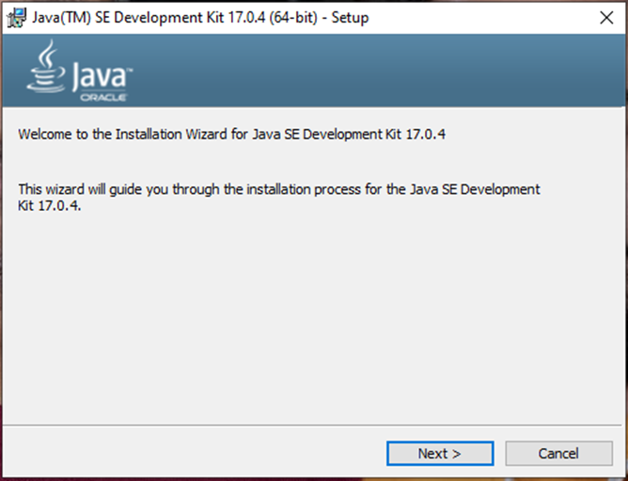

* + - Click on “Next”. A new window opens. You’ll have to wait till the process gets complete.

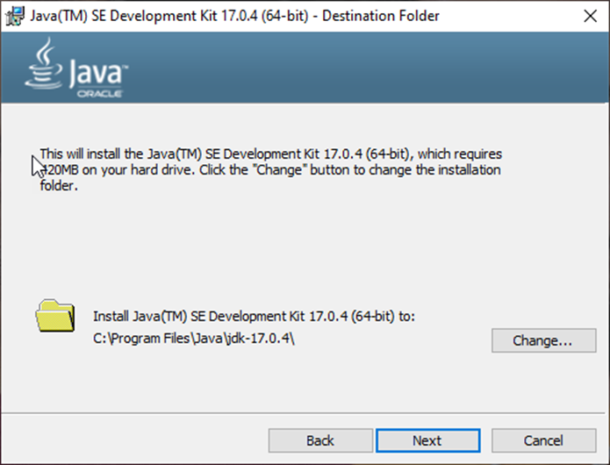

* + - Now, click the close button to finish the installation.

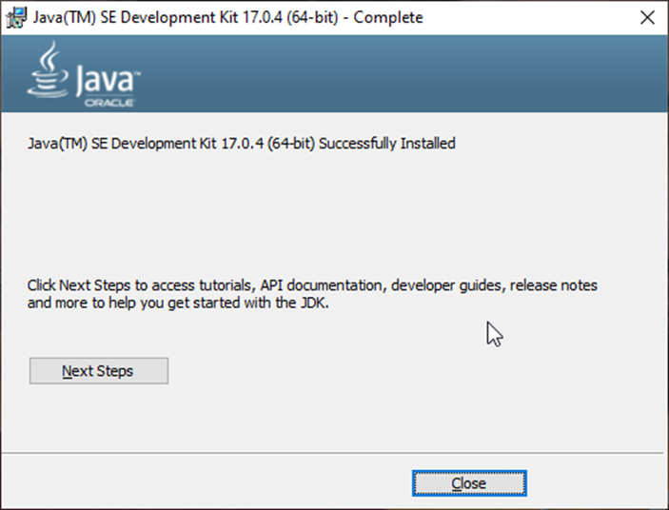

* Once Java has been installed on your machine successfully, you need to set the Java Environment Variable path on that machine by following the below steps:
* Select Control Panel >> System
* Click Advanced System Settings

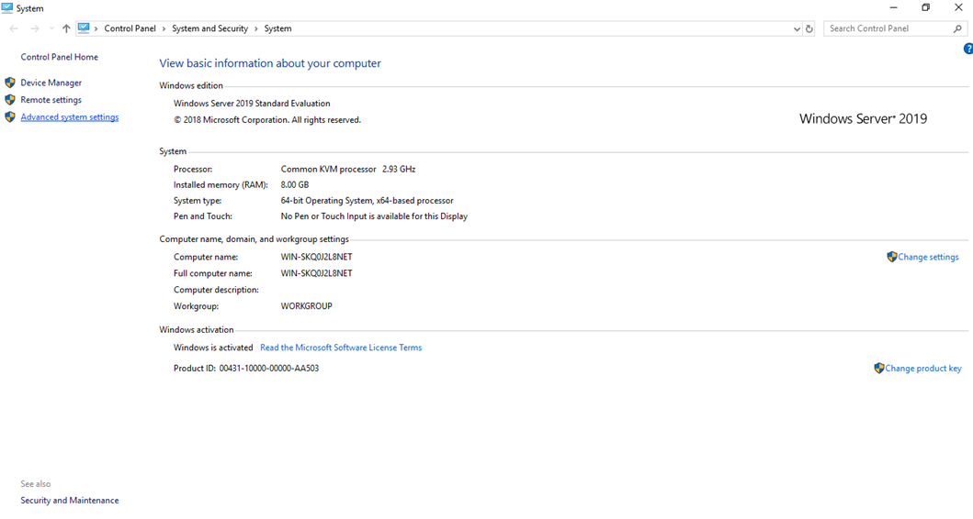

* Navigate to the advanced tab and click on the Environment Variables

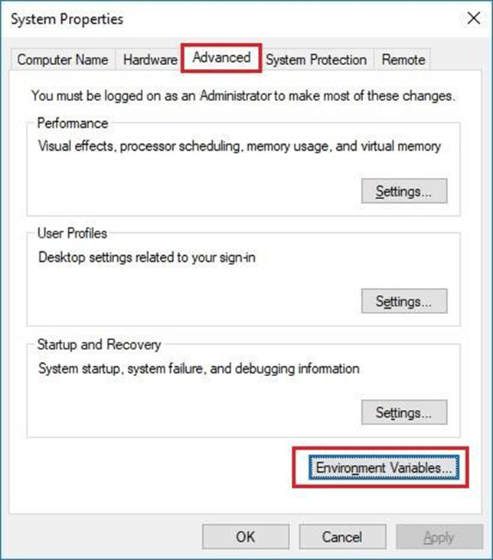

* Under System Variables section click on New
* Enter JAVA_HOME as Variable Name and the Path of installed JDK as Variable Value
* Click on OK

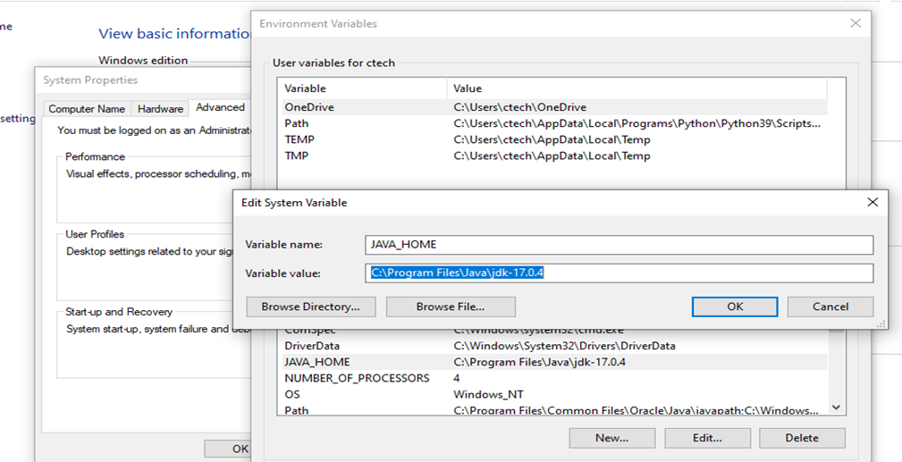

* You’ll also have to add the “Java Path” under “System Variable > Path” by clicking on the “Edit” option. Please refer to the image below.

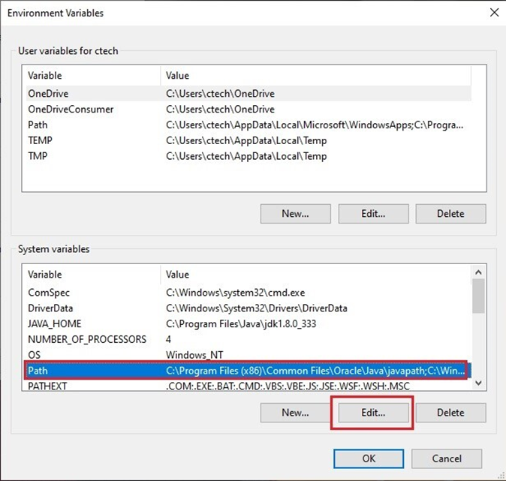

* Now, click on “New” and copy the JDK path as shown in the below image.

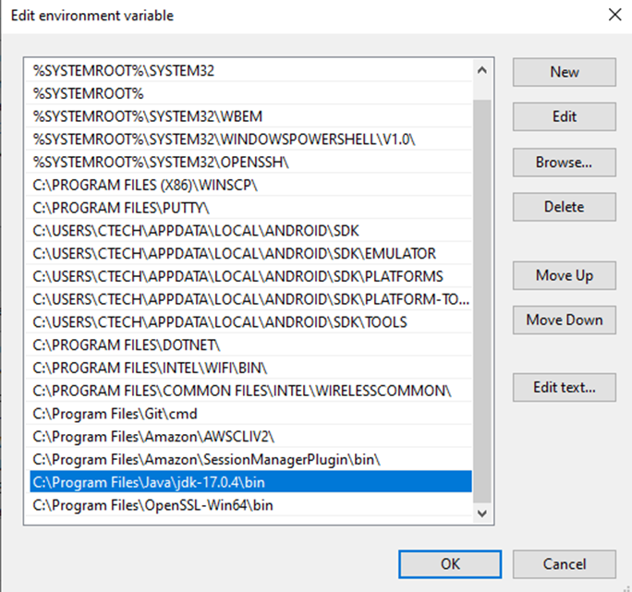

1. **Verification of .NET Framework version**

* Open command prompt and hit below mentioned command to verify the .NET framework version.

**reg query "HKEY_LOCAL_MACHINE\SOFTWARE\Microsoft\NET Framework Setup\NDP\v4\full" /v version**

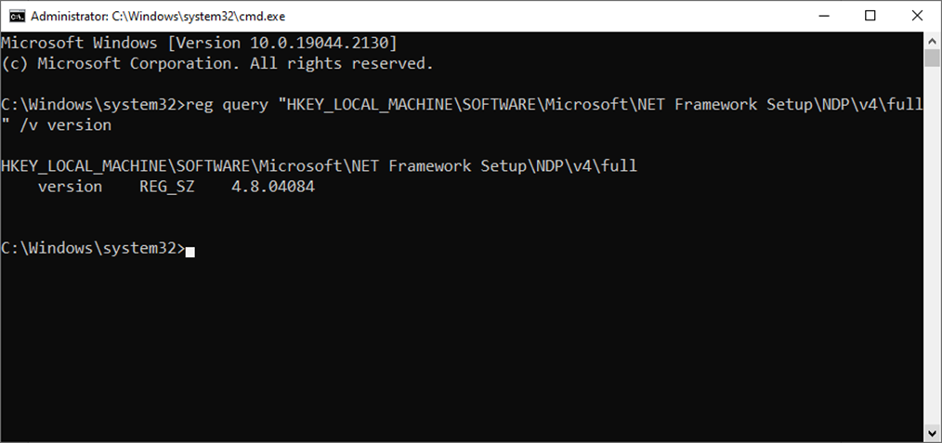

**Note –** Opkey requires .NET framework 4.8 or the latest version.

1. **Installation of Redis**

* Redis is an in-memory data structure store used as a database, cache and message broker. Before deploying Opkey on Windows machine, make sure that Redis is installed. Redis will be installed on App Server.
* Run the Redis application via administrator.

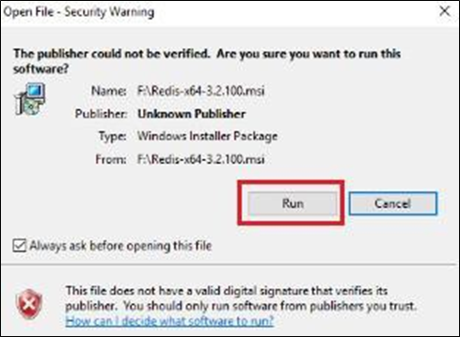

* Click next

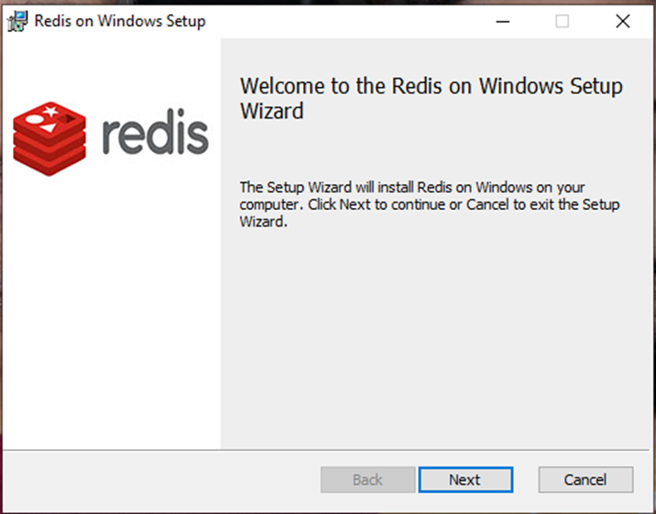

* Check the license agreement checkbox & click next to continue.

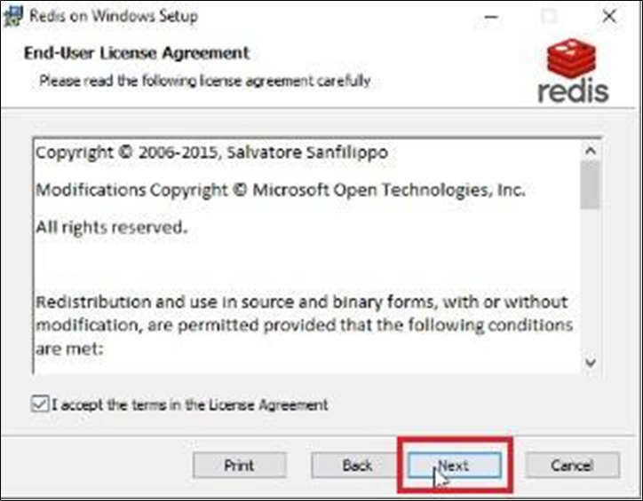

* Check on “Add the Redis…” and click Next to continue.

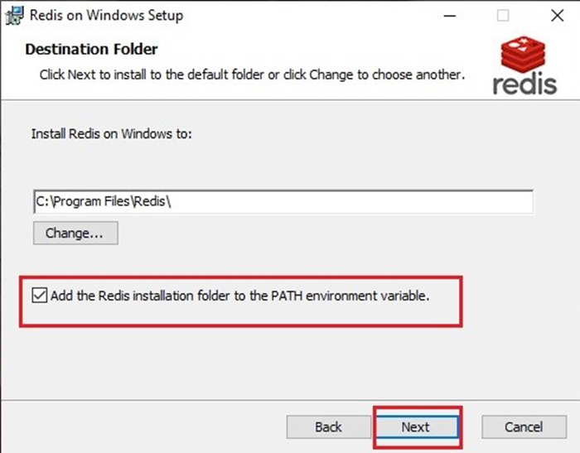

* Click Next to continue.

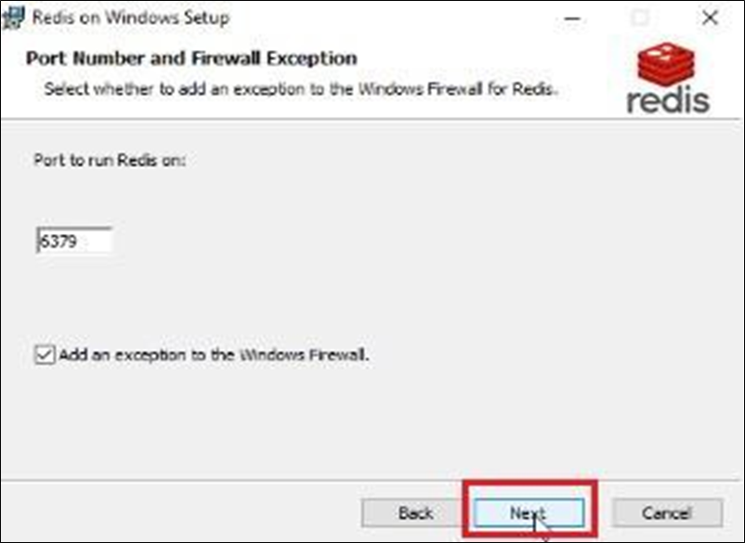

* Click Next to continue.

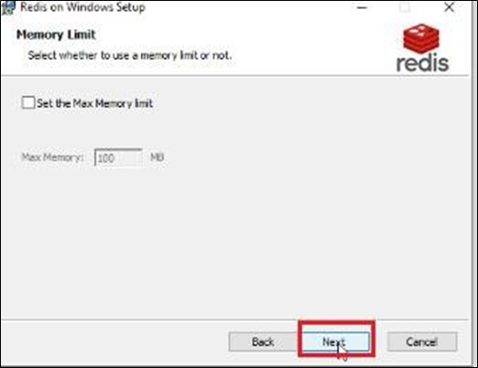

* Click Install to continue.

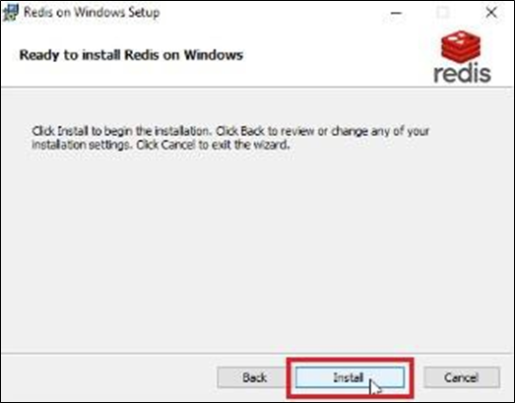

* The installation of Redis has been completed successfully.

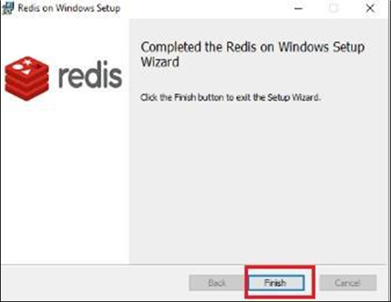

1. **Opkey Storage Folder Creation**

* Create a folder in D or E drive. The drive should have enough storage space as it will store the screenshots, jar files, etc. The folder must be created in the machine where we host File Server, and connectivity between that machine and the App Server and Database server must be established.

1. **Installation of MySQL Server and Workbench**

* Opkey requires MySQL Database version 8.0.37 which is installed on the database server machine.
* To install the MySQL Database server using the MySQL installer, double-click on the MySQL installer file and follow the steps below.

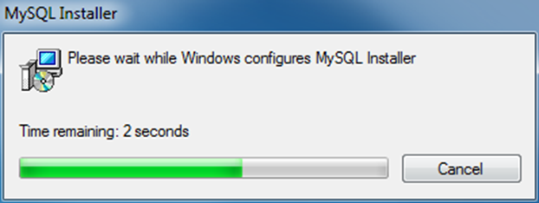

* License Agreement screen appears. Check License agreement checkbox and click next to continue.

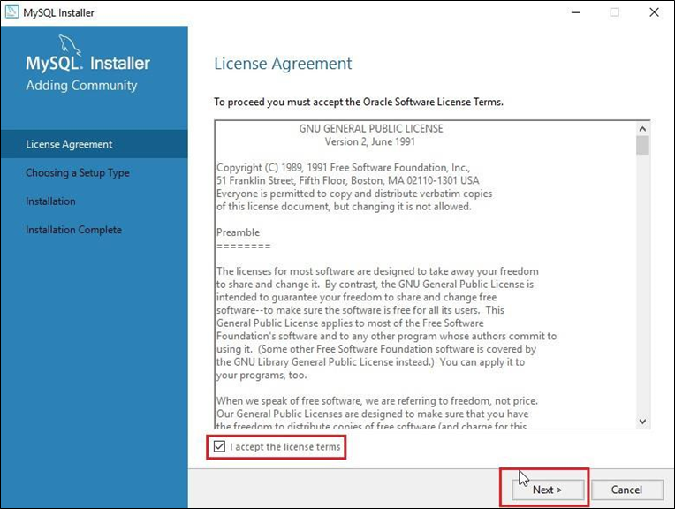

* There are several setup types available. Choose the Custom option to install only the required MySQL products and features. Click next to continue.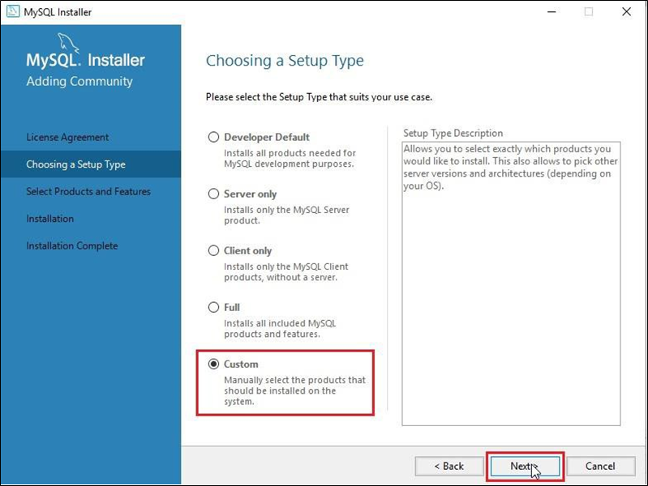
* Select MySQL Server 8.0.37 X64 and MySQL Workbench 8.0.36 X64 then place it to the right pane under the list of Products/Features to be installed. Click next to continue.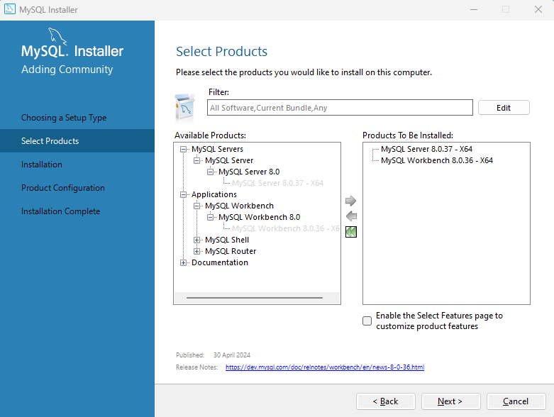

* MySQL Server 8.0.37 X64 and MySQL Workbench 8.0.36 X64 are ready to install on your machine. Click execute to continue then hit next.

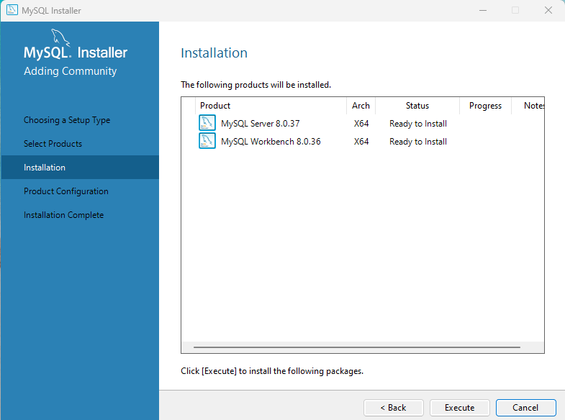

* Now, you must configure the MySQL server. Select Dedicated Computer in the drop-down menu and hit next.

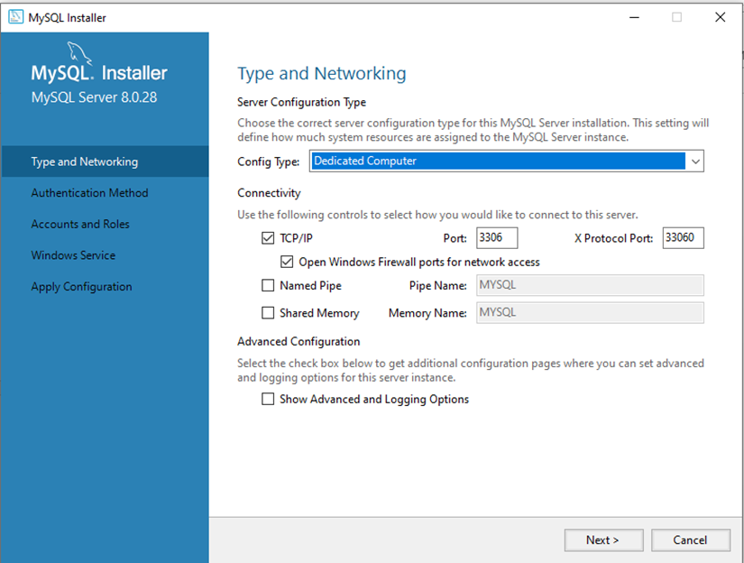

* Here, select the recommended settings and hit next.

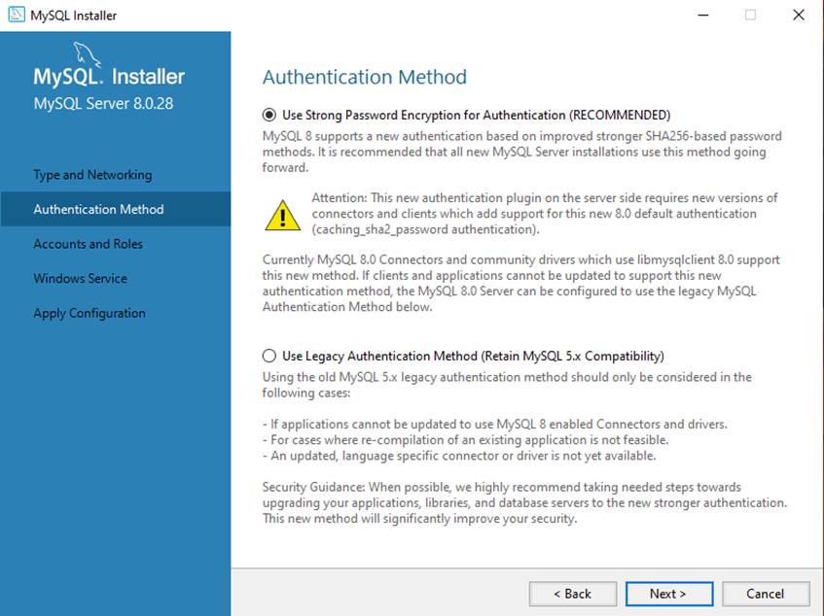

* Now, put the root user password and hit next again.

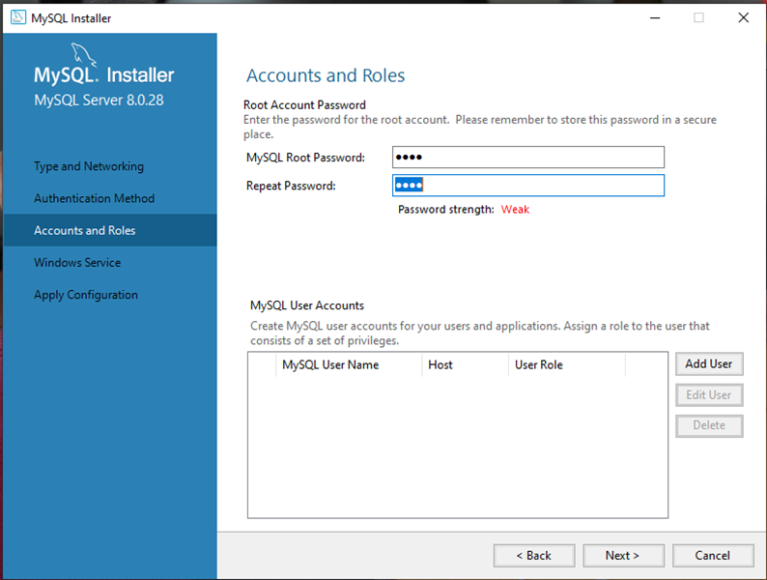

* Hit next again

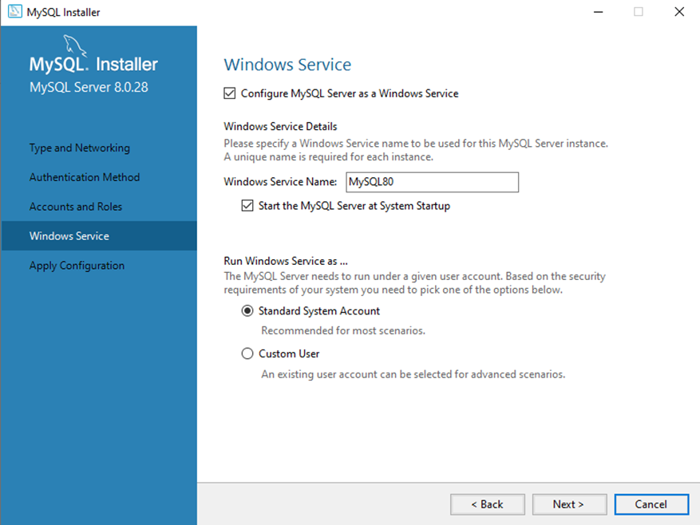

* Click on execute to begin the process and wait till it is complete. Then click on finish.

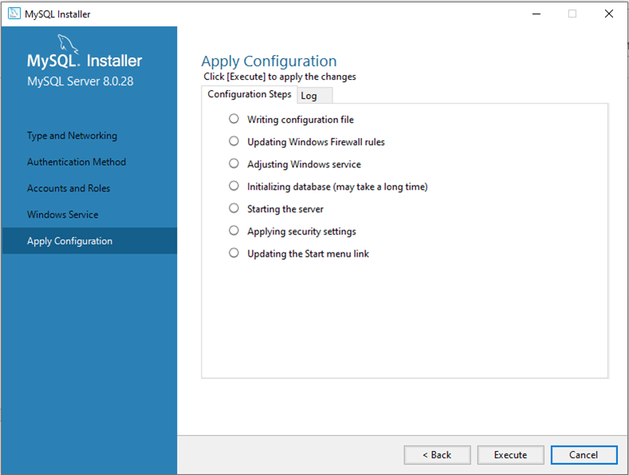

* Now click next again and click finish again.

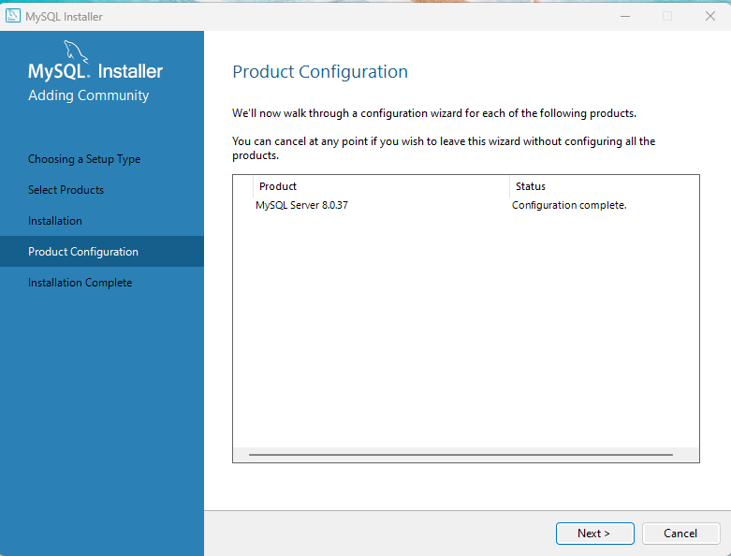

* MySQL server and workbench will be installed successfully. Post installation just hit next and uncheck ‘Start MySQL Workbench after setup’ and hit finish.

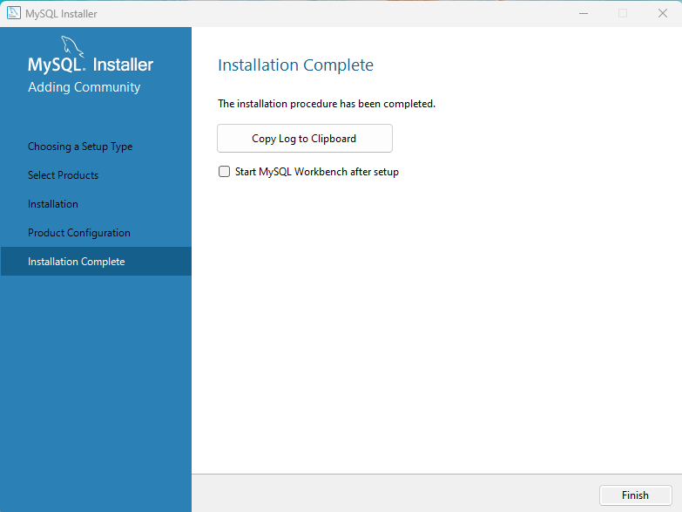

* Now open MySQL Workbench, select the Local Instance, enter the valid credentials and click OK.

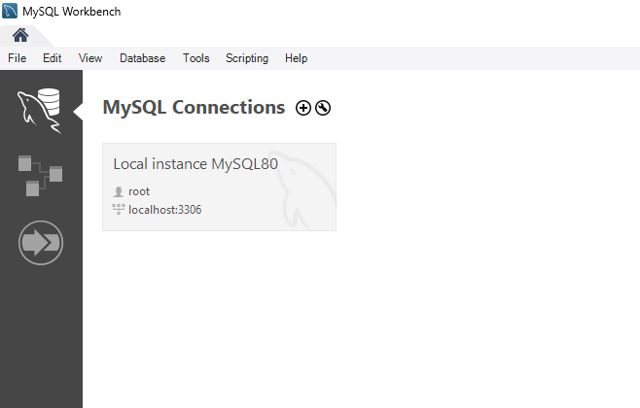

* Now, go to the “Administration” tab from the left pane and click on “Users and Privileges”

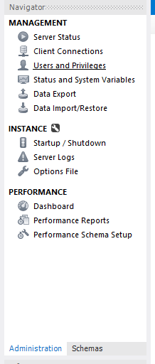

* Click on “root” user on the front page and type “%” in Limit to Hosts Matching then hit apply and close MySQL workbench. [This will allow root user to be accessible within the network]

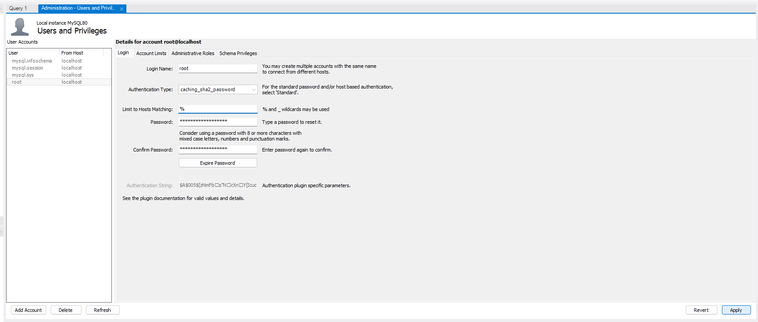

1. Database Tuning

* Database tuning is required so that the user can fully utilize server resources, due to which we get better performance.
* Open Opkey Database Optimizer jar file as an administrator (provided by the Opkey team) on the database server machine.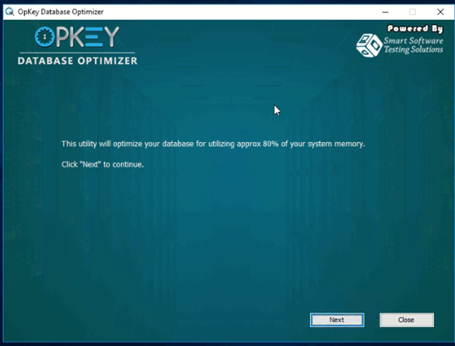
* Click on “Next” to continue.
* Put Database information here, MySQL username and the password then click next.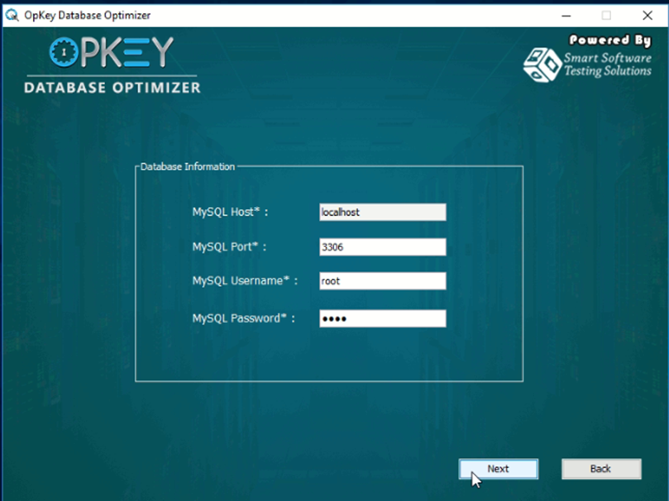
* Click on Optimize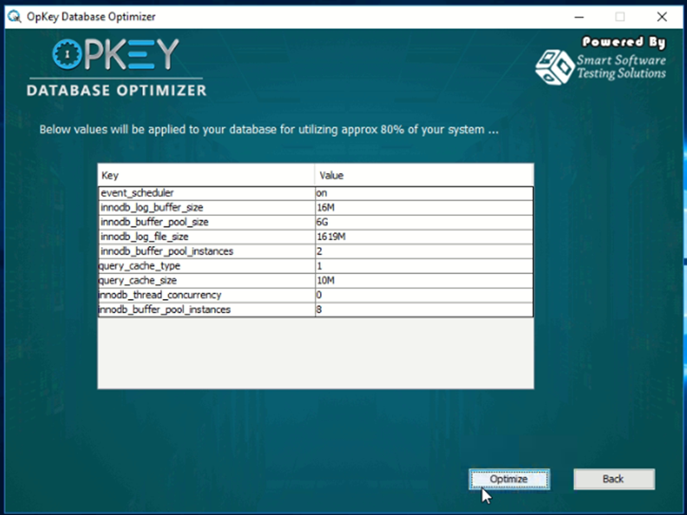
* Click on the “Finish” Button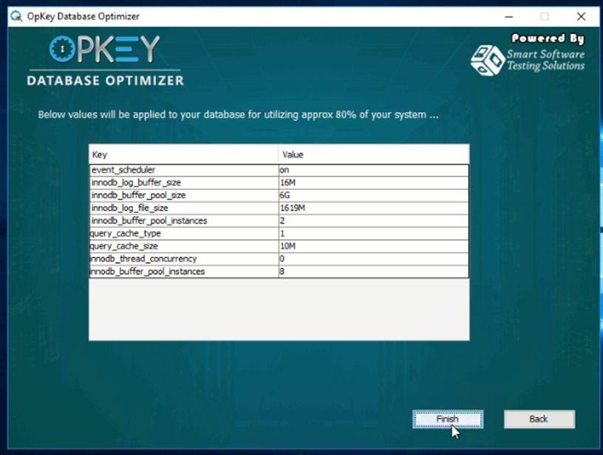
* Now, you need to restart the MySQL services.
* Go to the Start menu, type Services. Right click on it and select Run as Administrator

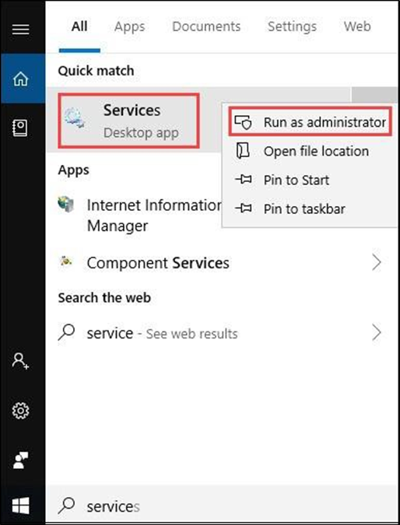

* Browse and select MYSQL80 and click on the Restart button to start its services. Make sure that the MySQL services have restarted successfully.

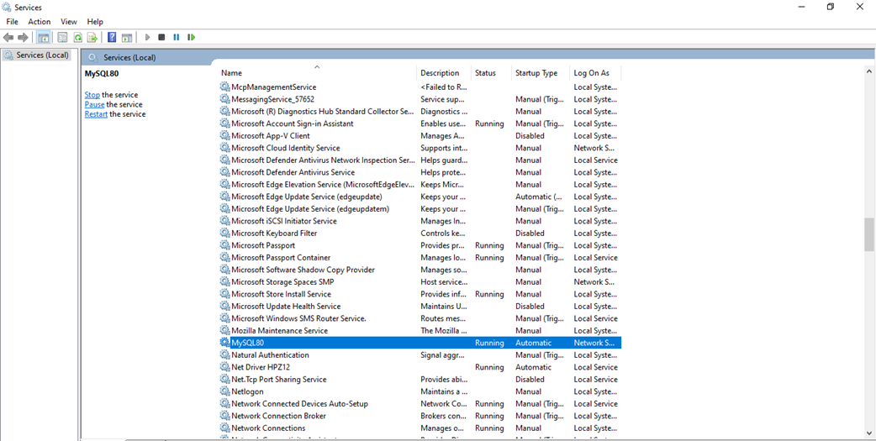

1. **Opkey Schema Creation**

* To create a new database (schema), you need **“Opkey-Database-Maintainer.jar”** and **“mysql-connector-j-8.0.32.jar”** files (provided by the Opkey team). You must open CMD and execute one command to create the Opkey database.
* First copy both files in a folder/desktop, then open the command prompt there.

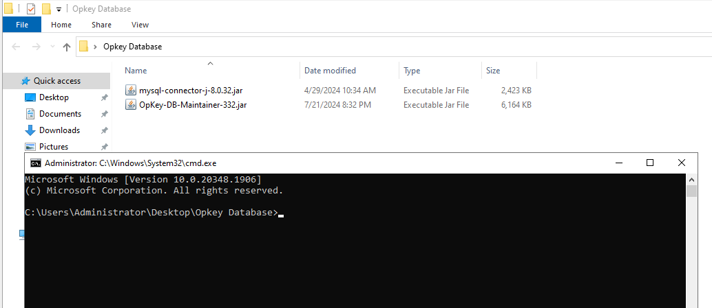

* Run below mentioned command to create the database

**java -classpath "OpKey-DB-Maintainer.jar";"mysql-connector-j-8.0.32.jar" com.crestech.opkey.maintenance.OpKeyDBMaintainer -mysql "IP/DNS" "PortNumber" "Username" "Password" "DatabaseName" "False" " False" -q**

|  |  |
| --- | --- |
| **Command** | **Explaination** |
| java | Java runtime environment command to run Java applications |
| -classpath | The -classpath option specifies the paths to the Java class files and libraries required to run the program |
| OpKey-DB-Maintainer.jar | Path of the Opkey Database Maintainer jar file |
| mysql-connector-j-8.0.32.jar | Path of the MySQL Connect 8.0.32 jar file |
| com.crestech.opkey.maintenance.OpKeyDBMaintainer | This is the fully qualified name of the main class to be executed from the OpKey-DB-Maintainer.jar |
| -mysql | Indicates the use of a MySQL database |
| IP/DNS | The IP address or DNS name of the MySQL server |
| PortNumber | The port number of the MySQL server |
| Username | The username to connect to the MySQL database |
| Password | The password to connect to the MySQL database |
| DatabaseName | The name of the database to maintain |
| False | This parameter is for SSL, and it should be False |
| False | This parameter is for TLS, and it should be False |
| -q | This option usually stands for "quiet" mode, which means the program will run without producing output to the console |

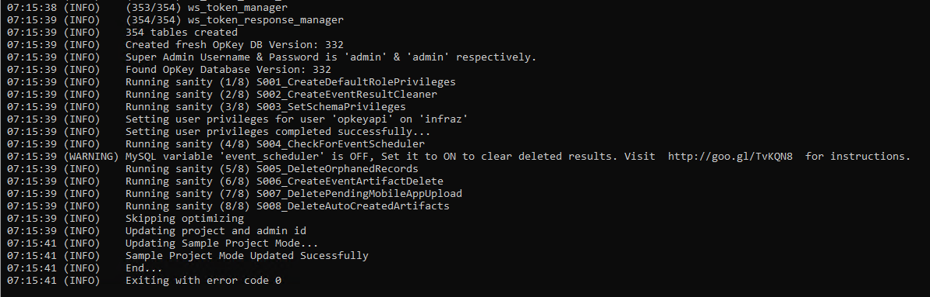

* Now, open MySQL workbench and select your database (which you’ve created) and execute below mentioned query.

**select * from main_users;**

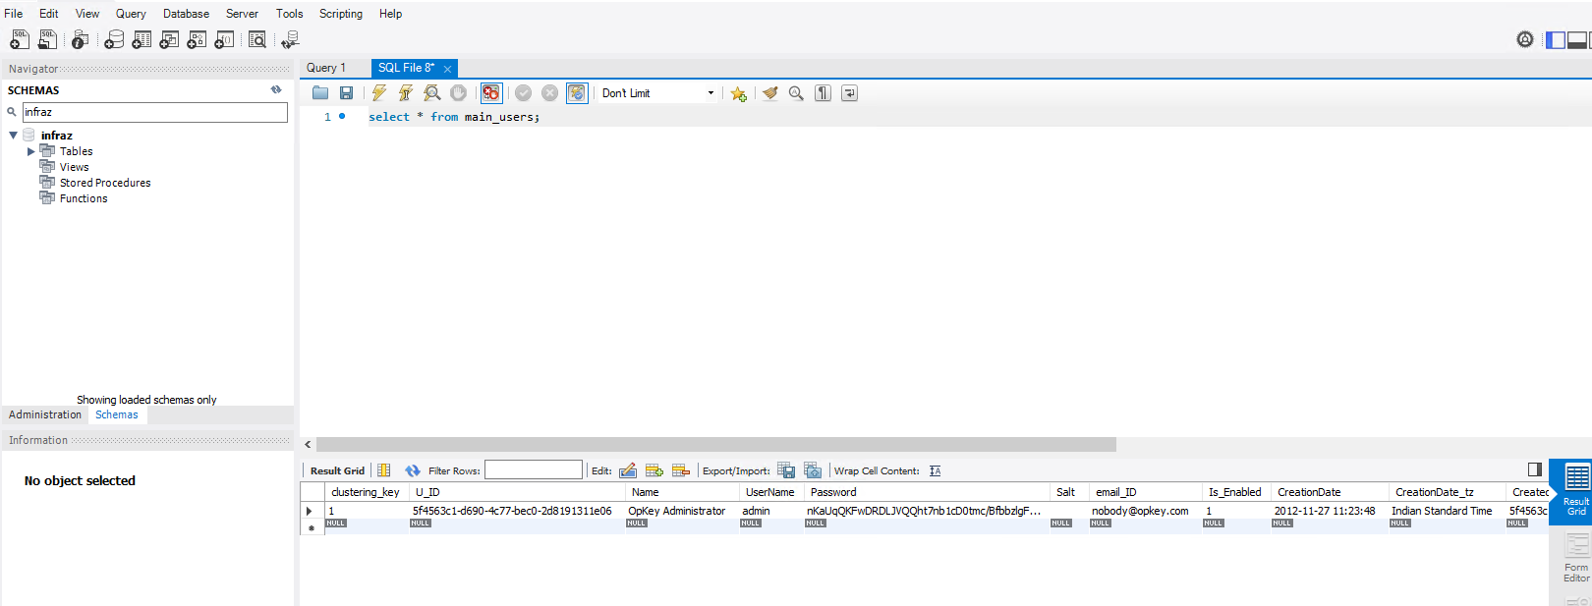

* Now you need to update the **Name**, **Username** and **Email_ID** columns with admin user’s details via below query.

**UPDATE `schemaname`.`main_users` SET `Name` = 'Kushal Gupta', `UserName` = 'kushal.gupta@opkey.com', `email_ID` = 'kushal.gupta@opkey.com' WHERE (`clustering_key` = '1');**

[NOTE: In the above query I have mentioned my details you have to put admin details]

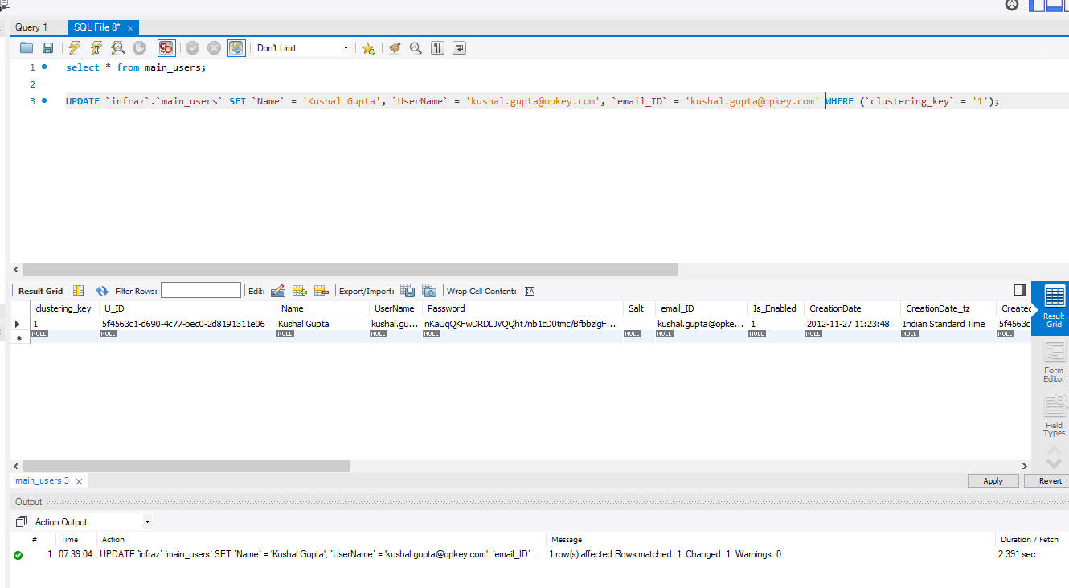

1. **Installation of MySQL .NET Connector 8.0.32**

* Opkey requires MySQL .NET Connector v8.0.32 to be installed on the App Server, Result Server, Marketplace Server, and Database Server.
* To install the MySQL .NET Connector kindly follow the steps below.

1. Run the application via administrator and hit next

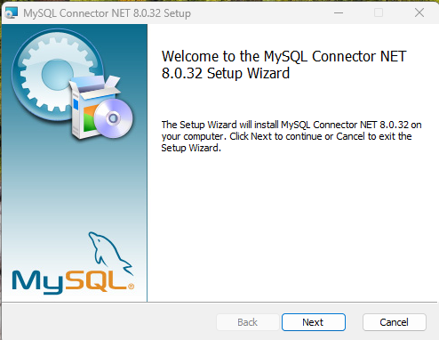

* Select **Complete** and hit **Install**

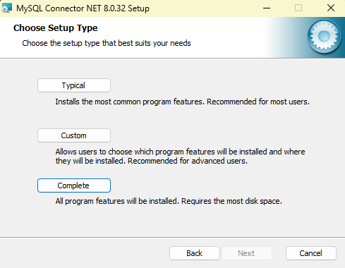

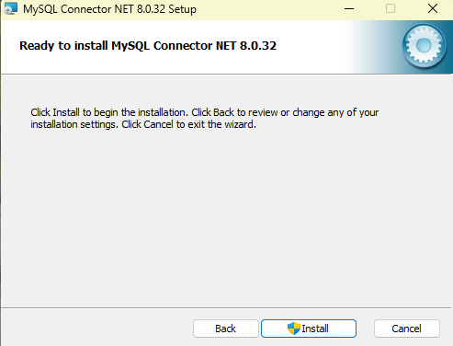

* Wait till it complete and hit finish

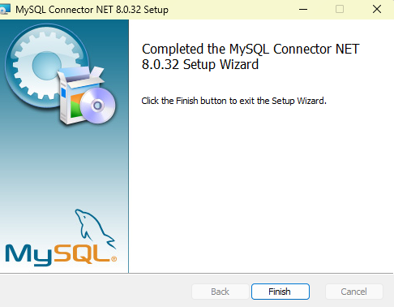

1. **Installation of IIS Manager**

* Internet Information Services (IIS) is a Windows Server feature installed by using Server Manager. IIS Server installation is quick and easy and will be installed on App Server, Result Server, Reporting Server, Marketplace Server, and UI Server.
* Open the Server Manager and click Add Roles and Features

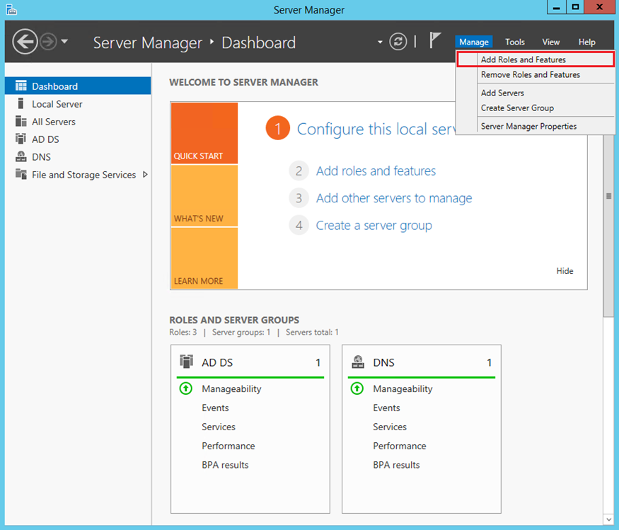

* Add Roles and Features
* Click Next

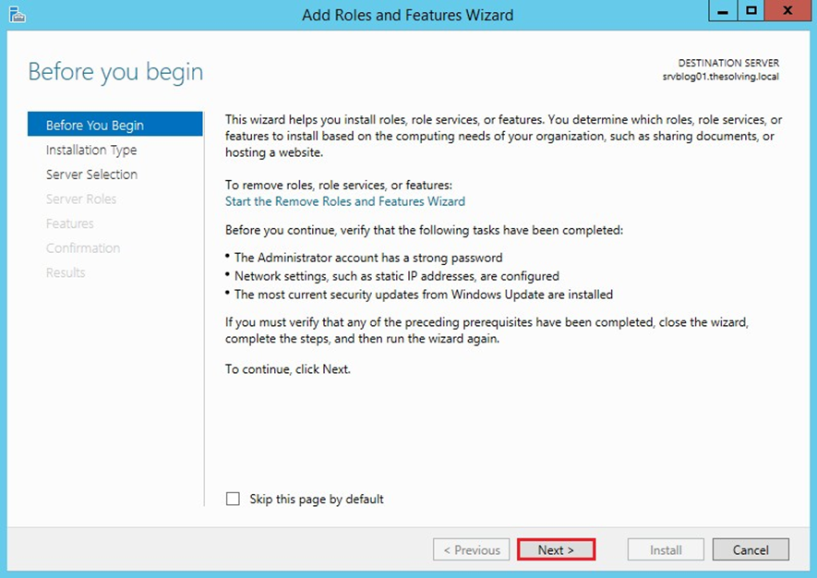

* Select Role-based or feature based installation and click on Next

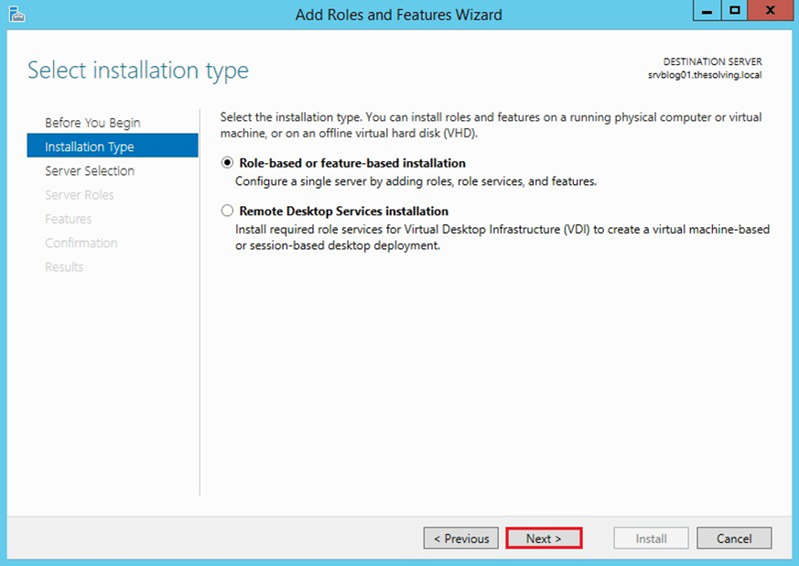

* Select the Destination Server and click on Next

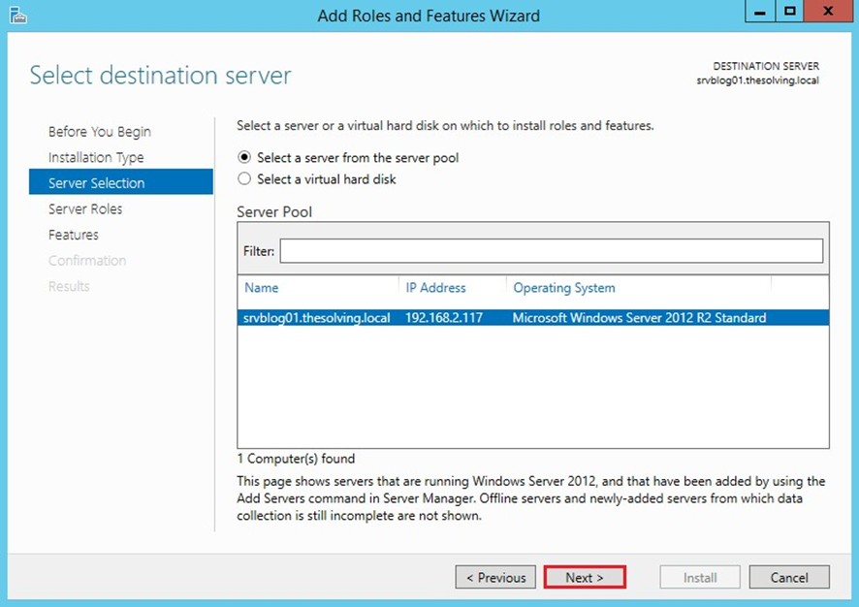

* Select Web Server (IIS) role and click on Next

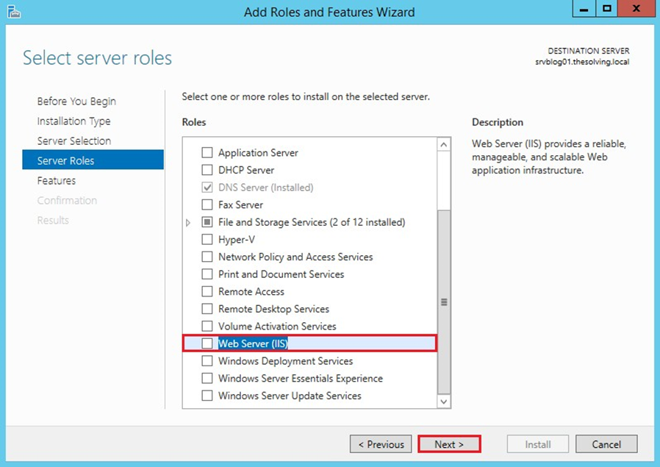

* Click Add Features

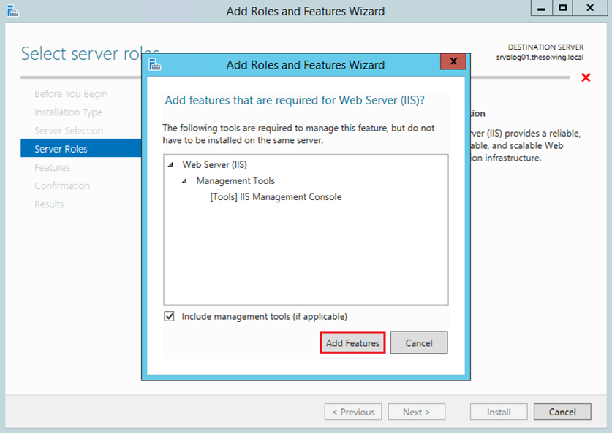

* You don’t need to edit any settings here and click Next

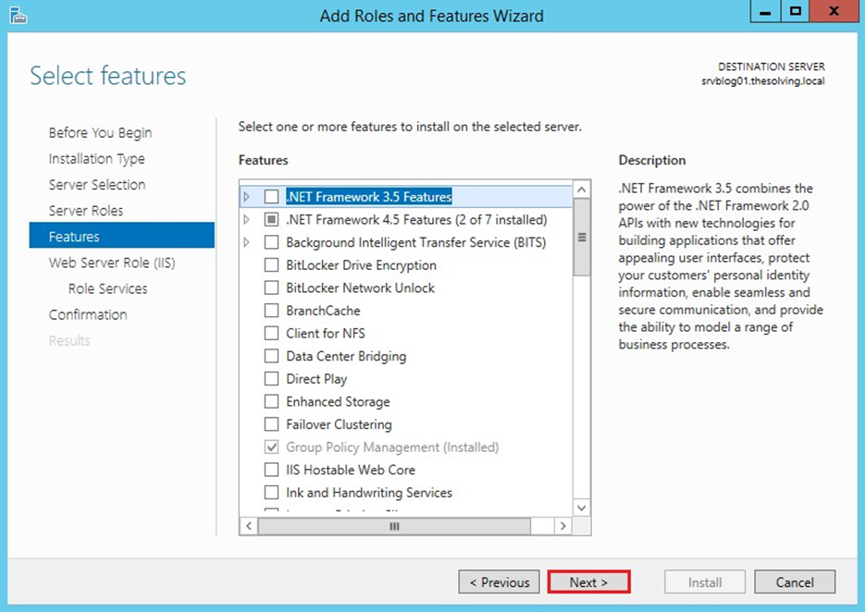

* You don’t need to edit any settings here and click Next

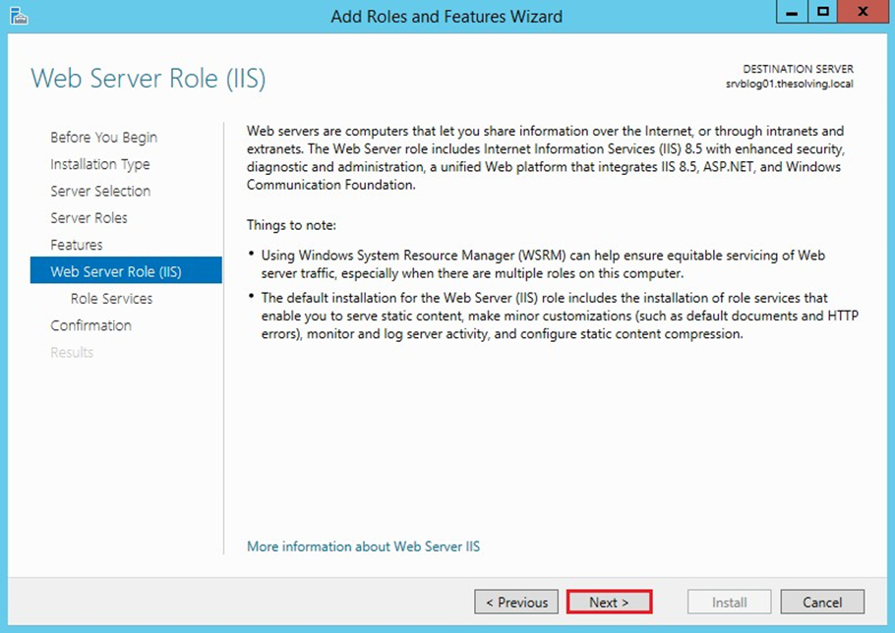

* Now, select the components as mentioned below.

Under **“Health and Diagnostics”,** select below components

* Request Monitor Tracing

Under **“Performance”** select

* Dynamic Content Compression

Under **“Security”** select

* Basic Authentication
* URL Authentication
* Windows Authentication

Under **“Application Development”** select

* .NET Extensibility 4.7
* Application Initialization
* ASP
* ASP .NET 4.7
* ISAPI Extensions
* ISAPI Filters
* Web Socket Protocol

[While selecting these features you will get the popup to **“Add Feature”,** remember to select add feature every time]

* Post selecting these features click Next

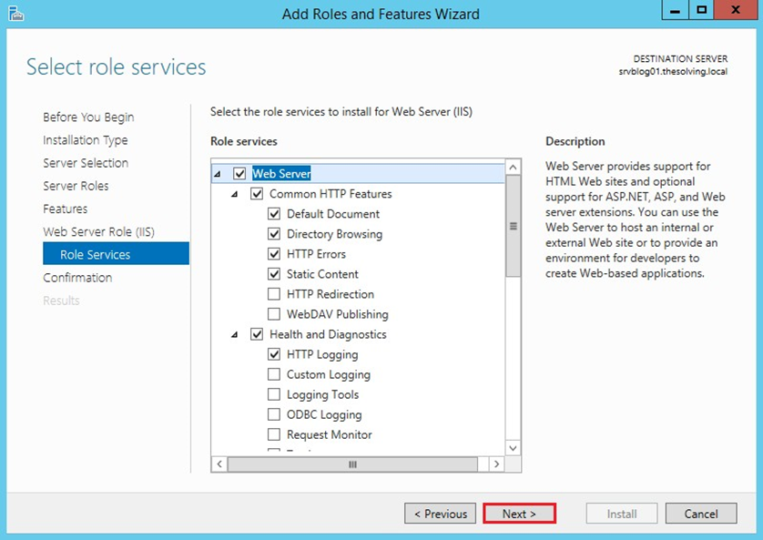

* Select “Restart the destination server automatically if required” and Click Install

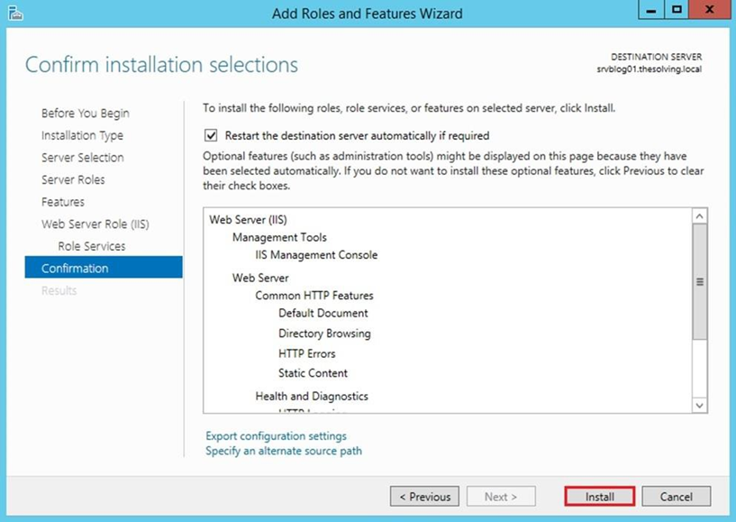

* Installation of IIS Server is now completed successfully.
* Click on Close

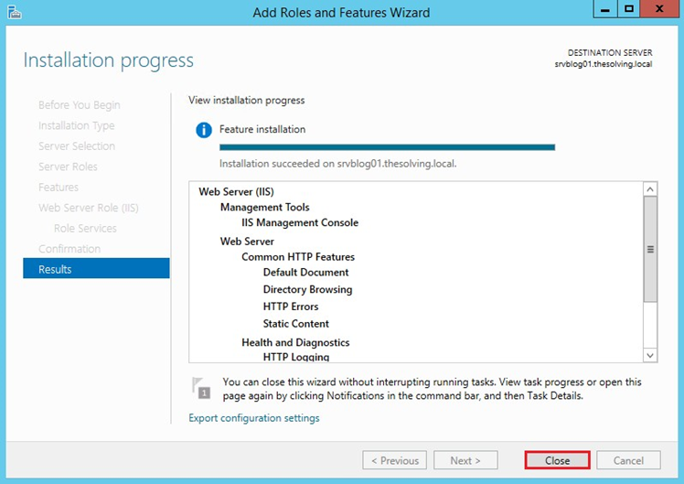

**10. Installation of ARR and URL Re-Write**

* The ARR and URL re-write IIS components will be installed on App Server and the UI Server.
* Run the application via administrator and follow the steps below.
* **URL Re-Write:** Accept the License Agreement and click Install.

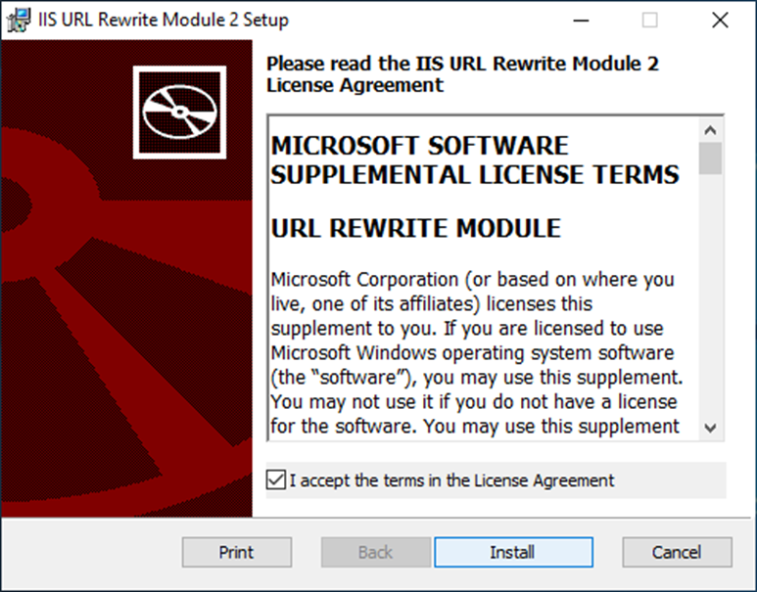

* It will automatically install the URL-Rewrite then click on finish.

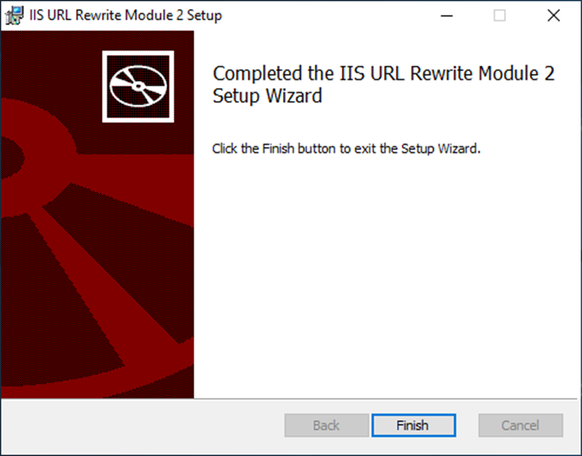

* **ARR:** Accept the License Agreement and click Install.

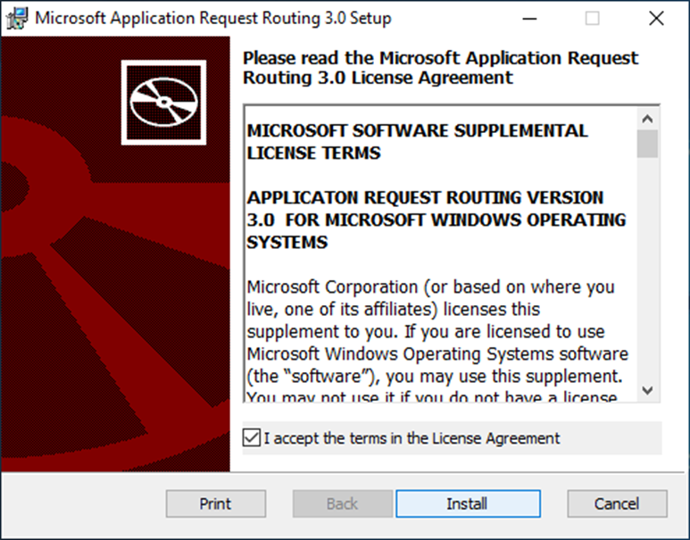

* It will automatically install the ARR then click on finish.

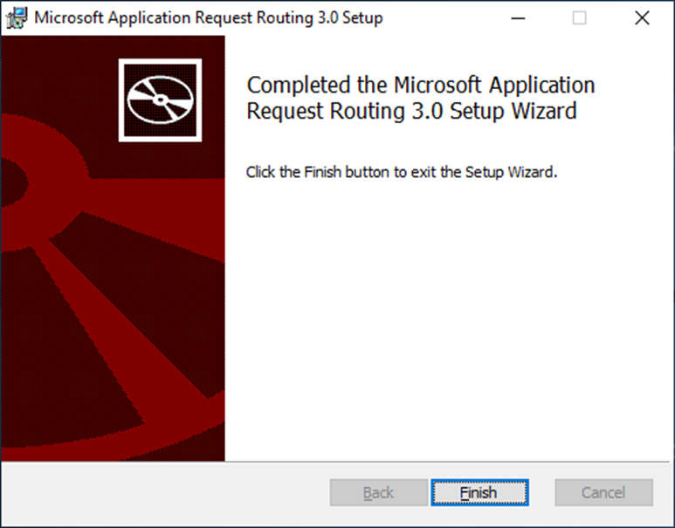

**11. Installation of ASP.NET Core Runtime 8.0 Hosting Bundle**

* This application will be installed on the Result Server.
* Run the application and accept the terms and conditions.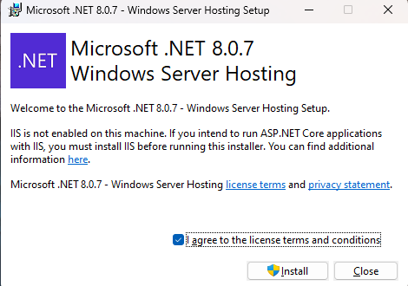
* Hit close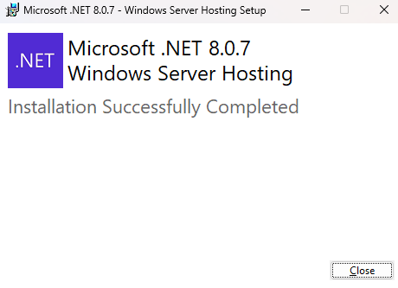

**12. Installation of Node JS v16.13.1**

* This application will be installed on the Marketplace Server.
* Run the application and hit next

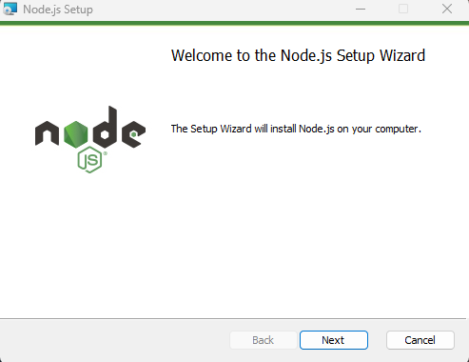

* Now accept the License Agreement and hit next

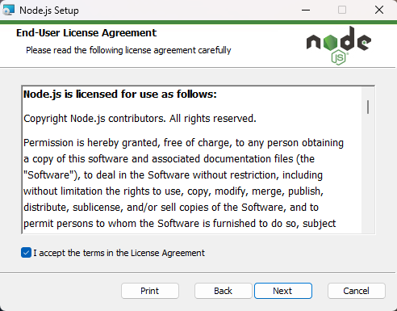

* If you want to change the installation folder here, you can change or keep this default and hit next

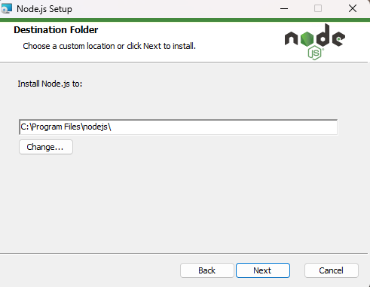

* Now, hit next again

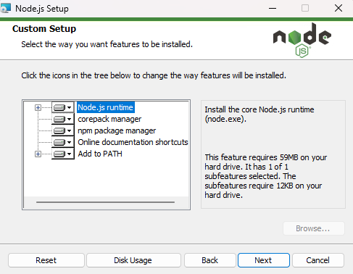

* Now hit next again

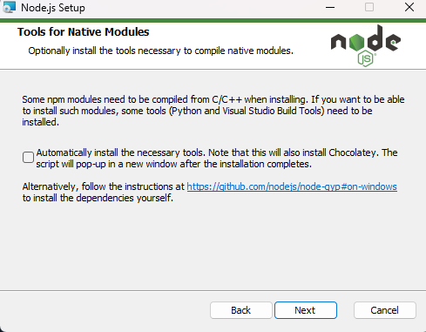

* Now hit Install and it will start the installation

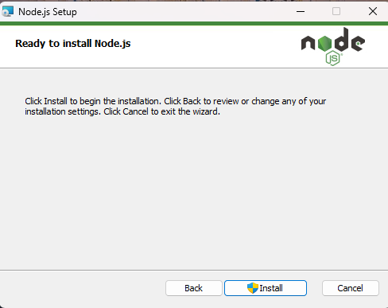

* Post installation you will get this screen and hit finish

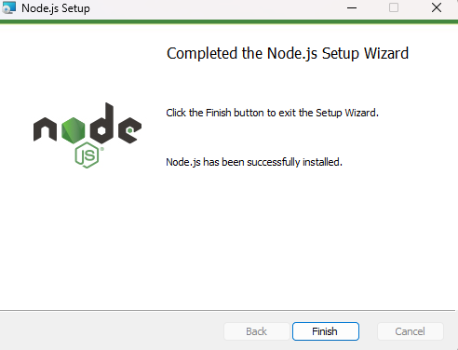

**13. Installation of MongoDB Server 4.2.23 Community Edition and MongoDB Compass**

* MongoDB is an open-source No-SQL database that uses a document-oriented data model which we use to store Opkey Marketplace add-on data and Opkey’s Test Discovery database. You can install this application on Marketplace Server, and it can be used for both Marketplace and Test Discovery applications.
* Run the application and hit next

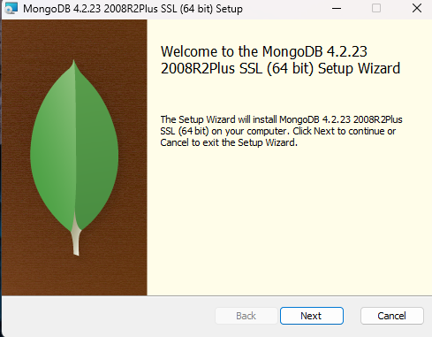

* Then accept the License Agreement and hit next

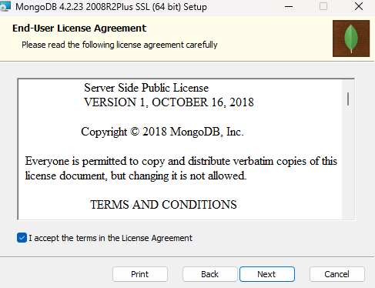

* Now select **Custom**

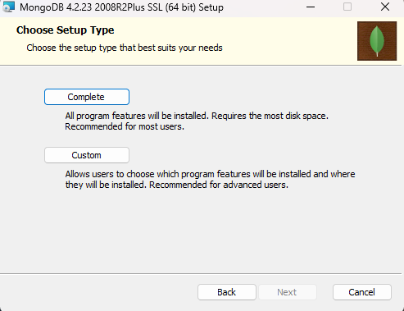

* Now hit next

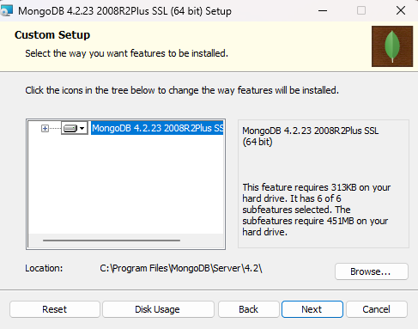

* Again, hit next

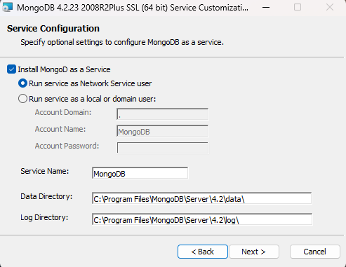

* Now you need to uncheck **“Install MongoDB Compass”** and hit next

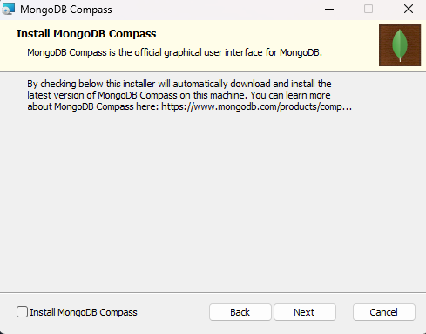

* Now hit **Install**

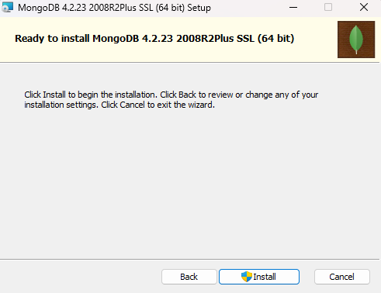

* Post installation you will see this, now hit finish

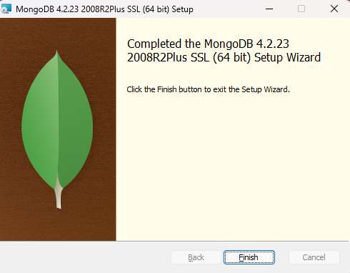

* Now we will install MongoDB Compass. Run the application via administrator and it will be installed automatically.

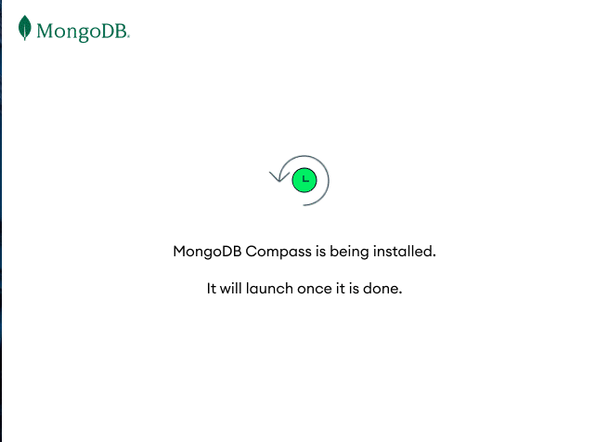

* Post installation, it will run automatically

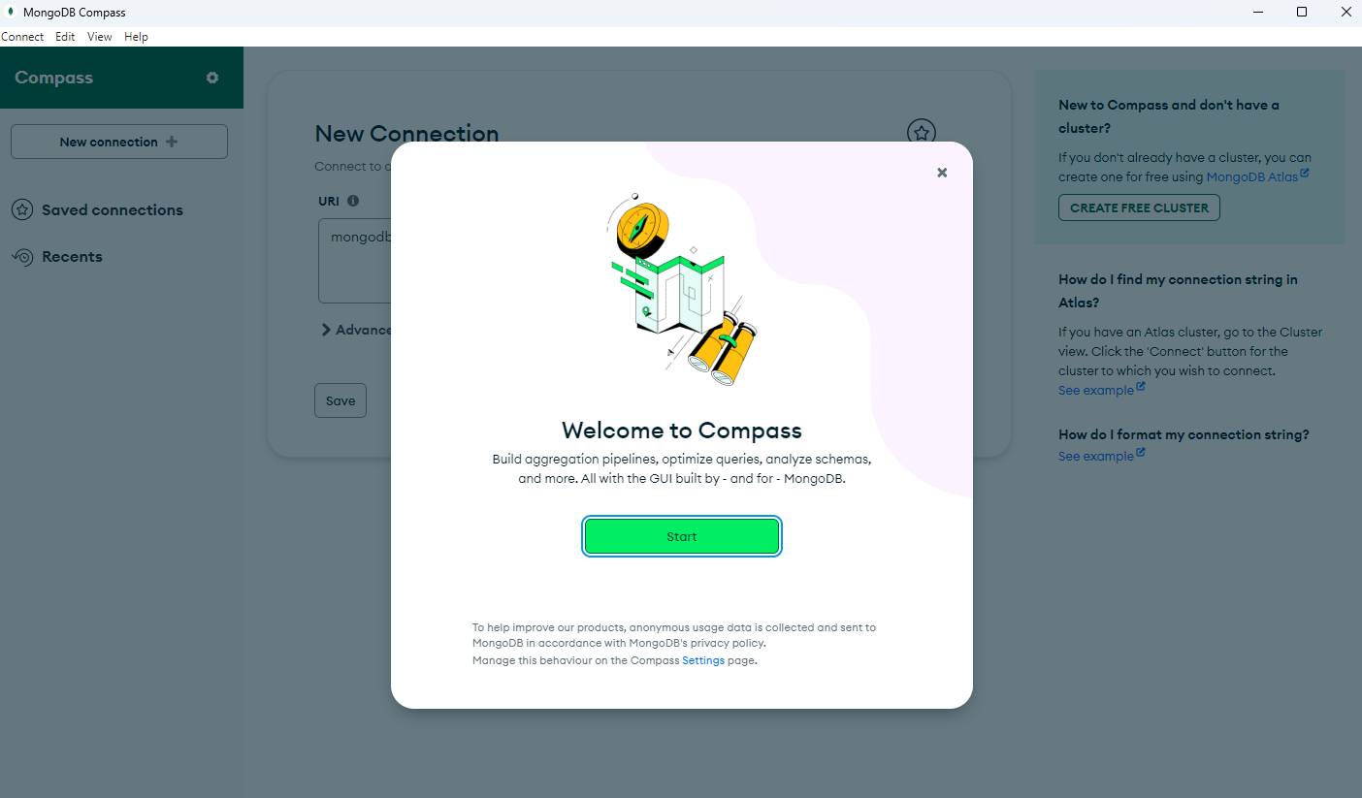

* After the installation is complete, open the MongoDB server installation folder and go to **“Server/4.2/bin”** and open **“mongod.cfg”** in a notepad and edit network interface bind IP value to default IP address and save it.

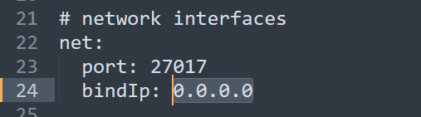

* Now restart the MongoDB Server service from Windows Services

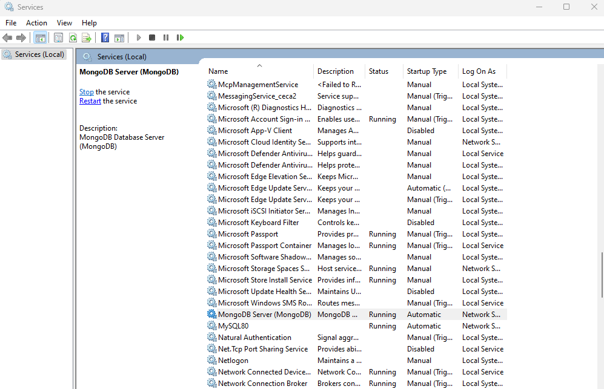

**14. Installation of Elasticsearch and Kibana v8**

* Copy Elasticsearch and Kibana zip files in a folder in C or D drive and extract it.

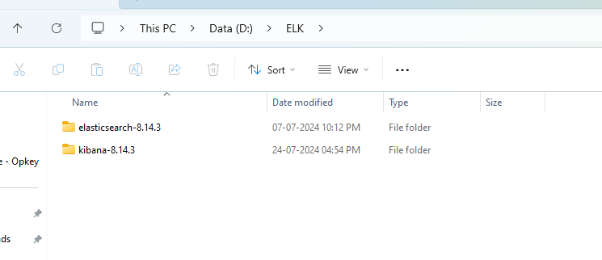

* Now first we will start Elasticsearch. So, open Elasticsearch folder and open config folder and edit **“jvm.options”** fille. Make two entries **“-Xms4g”** and **“-Xms4g”** at the end of the document as shown below.

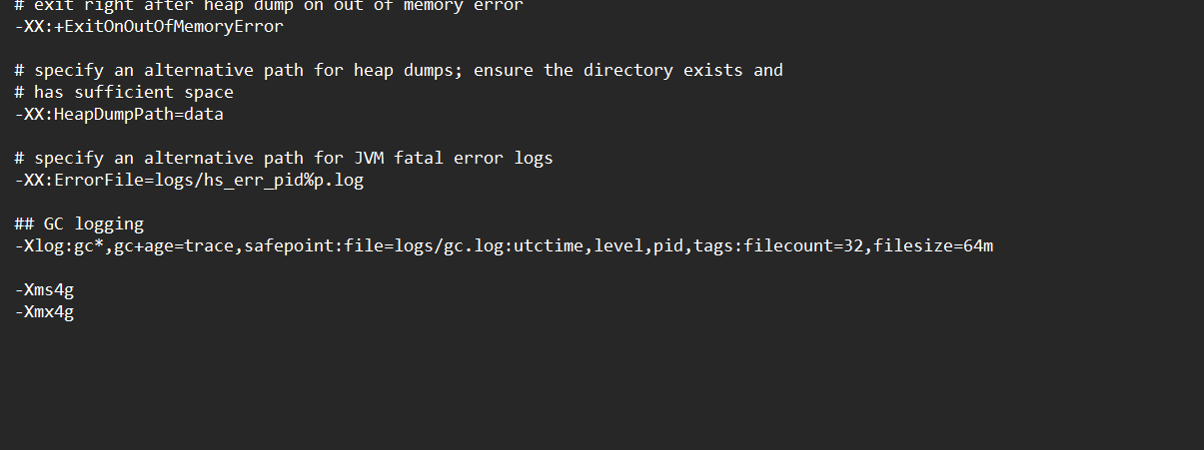

* Now open bin folder of the Elasticsearch and open CMD there then run **“elasticsearch.bat”** file.

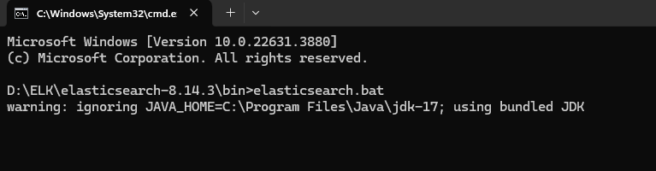

* Now wait for 5 to 10 minutes, once you will see information about SSL encryption and admin credentials just close the application like shown below.

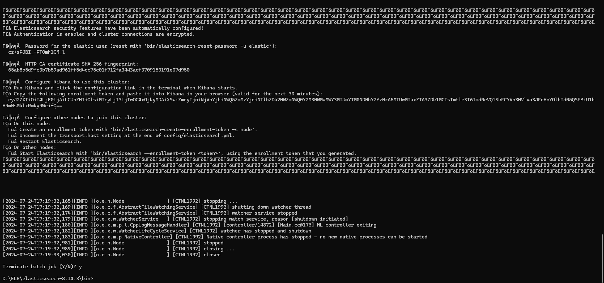

* Now again open config folder and now edit **“elasticsearch.yaml”** file and change some values and save it as shown below in the image.

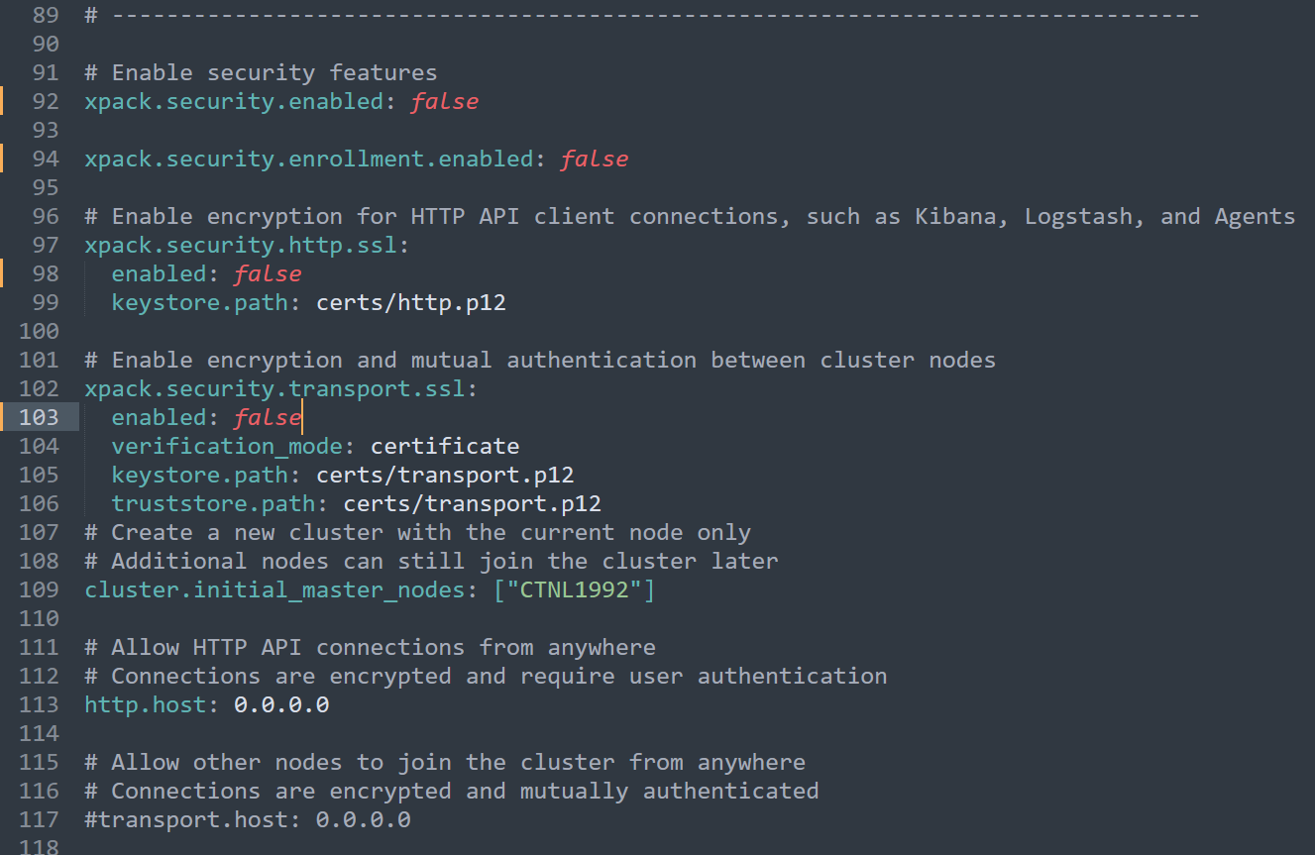

* Now open the bin folder again, open CMD and run **“Elasticsearch.bat"** then Elasticsearch will start in some time you can check it by opening it on a browser with the default URL.

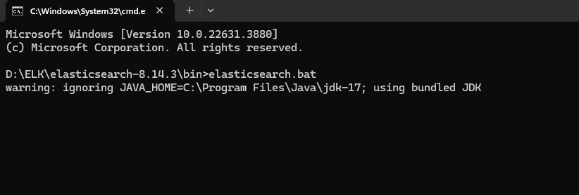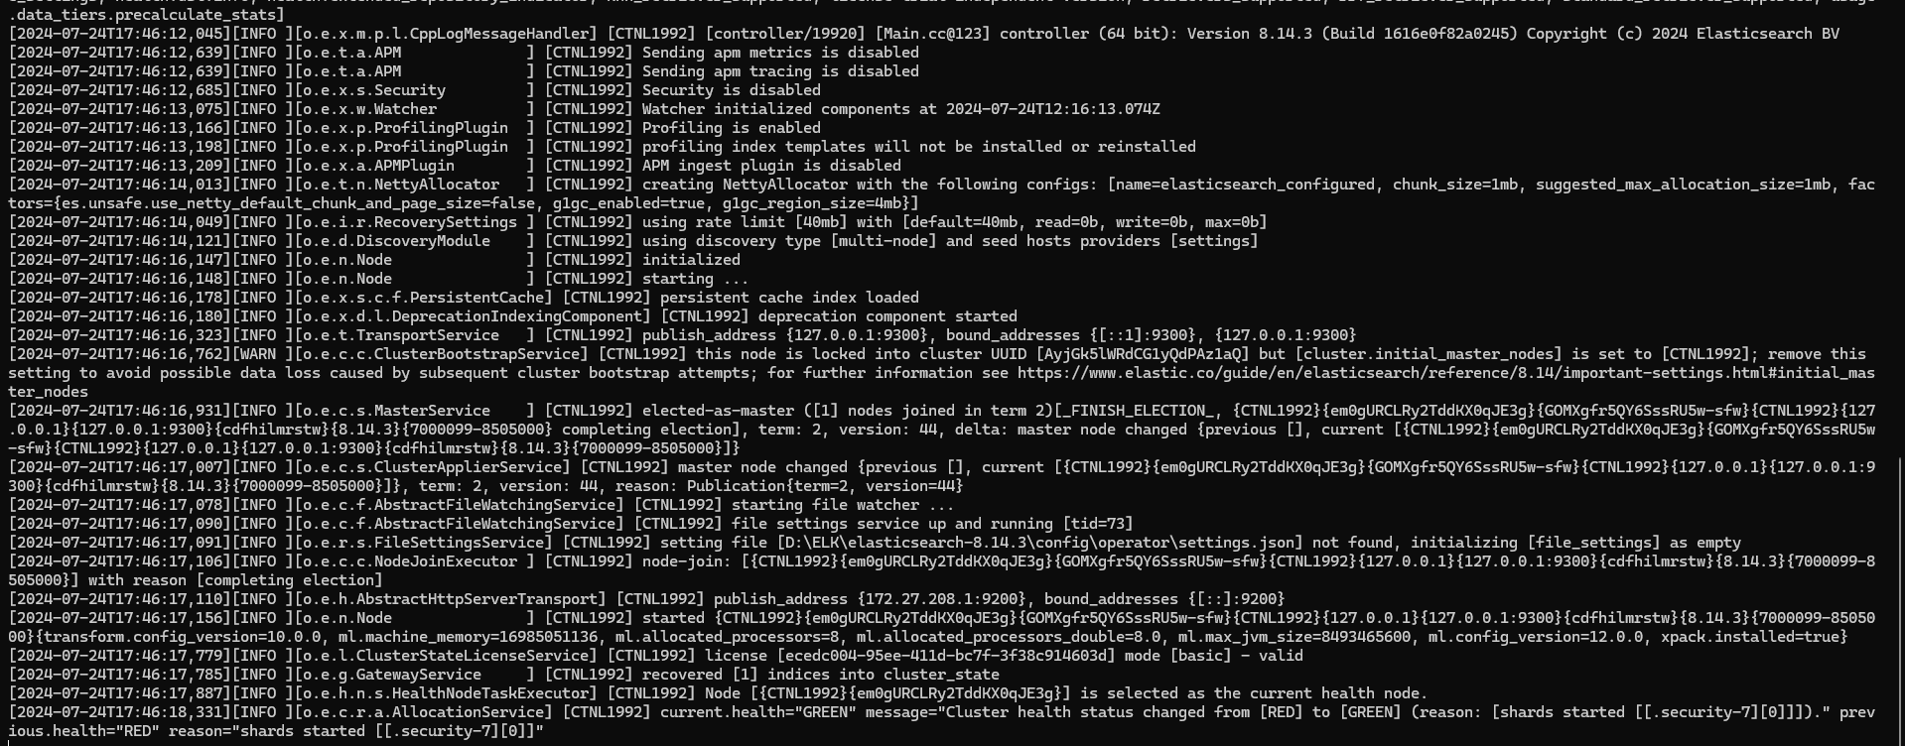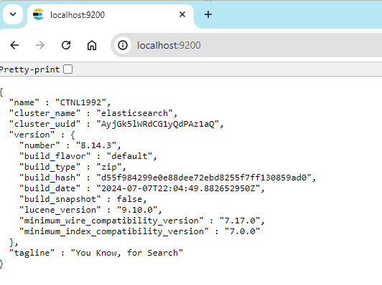

* We will start Kibana now. So, open Kibana folder and open config folder and edit **“kibana.yaml”** file and change some value as shown in the image below.

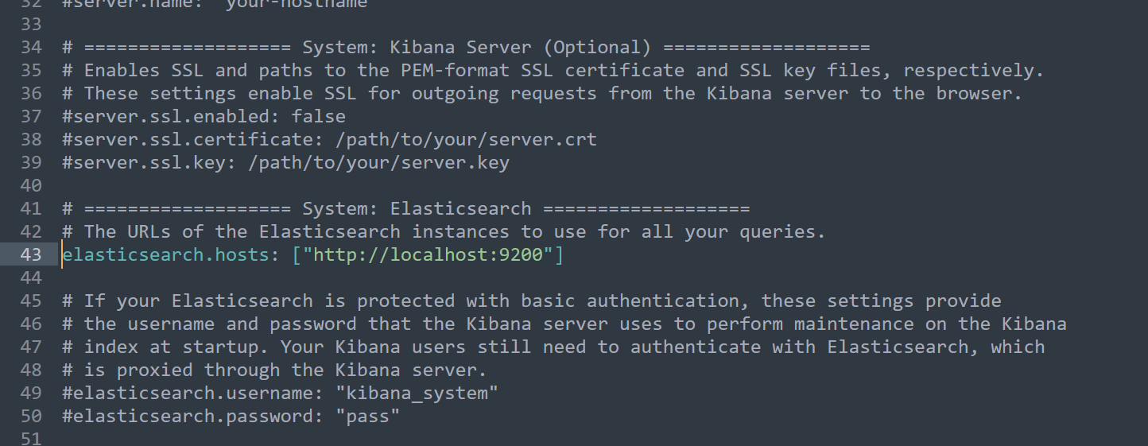

* Now open the bin folder, open CMD and run **“Kibana.bat"** then Kibana will start in some time you can check it by opening it on a browser with the default URL.

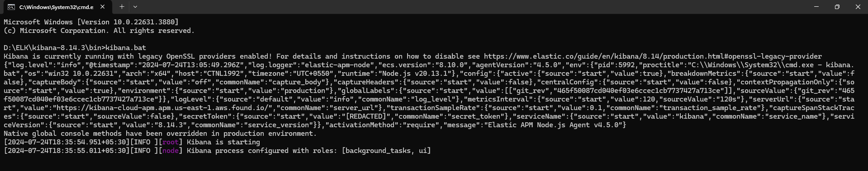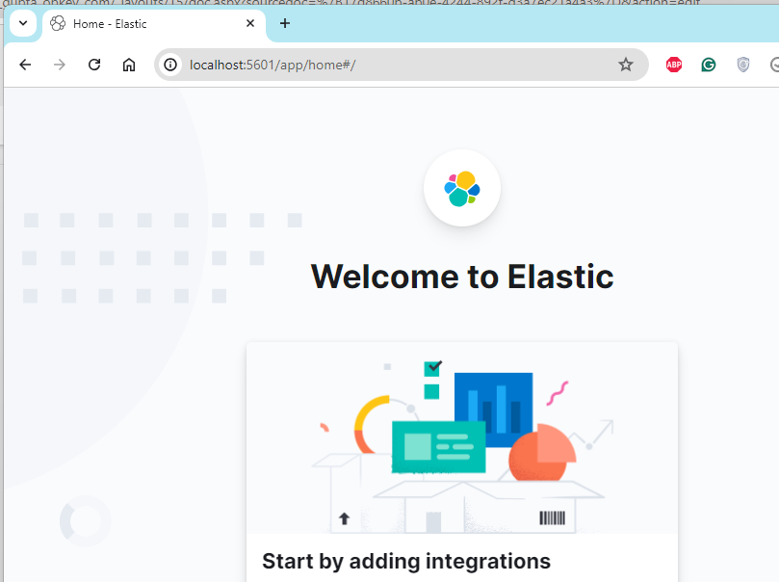

**15. Installation of KeyCloak v24.0.2**

* Keycloak is an open-source identity and access management solution for modern applications and services. It is designed to provide single sign-on (SSO) capabilities, user federation, client adapters, and more. This application will be installed on Keycloak Server.
* Copy the Keycloak zip file and paste it in a folder in C or D drive then extract it and follow the steps below. **[You must have SSL certificate file and its key file to host Keycloak on SSL]**

1. First, we will create a database and credentials for Keycloak to store all of its data in the MySQL server. So, open MySQL workbench and connect to the server and execute the commands as shown below one by one.

* create database **databasename**;
* create user **'username'@'%'** identified by **'password'**;
* grant all privileges on **databasename.\*** to **'username'@'%'**;

1. Now open conf folder inside Keycloak folder and copy SSL certificate and its key file here then edit **“keycloak.conf"** file and replace the values as follows.

* db
* db-username
* db-password
* db-url
* https-certificate-file
* https=certificate-key-file
* proxy

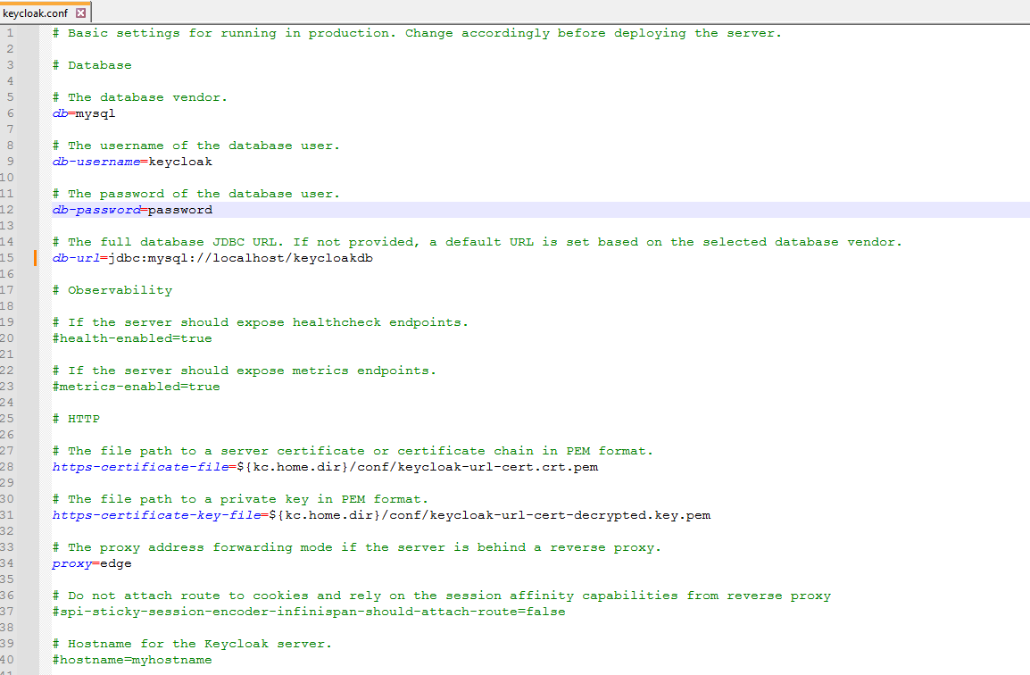

1. Now go inside bin folder in Keycloak folder and open a command prompt here

* First run **kc.bat build**

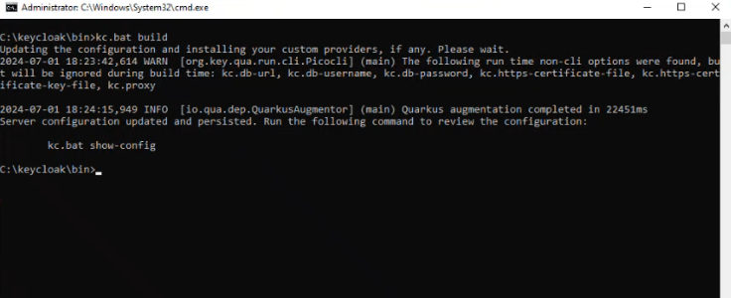

* Then run command **kc.bat start --hostname-strict=false** to run keycloak in production mode (It will only work if the certificates are added in the config file)



* After this Keycloak server will start on HTTPS protocol and on 8443 port number. You can check by opening the default URL (<https://localhost:8443>) on a browser.

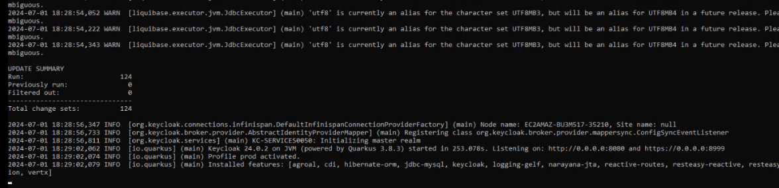

* Now you need to create Admin (root) user credentials for Keycloak portal

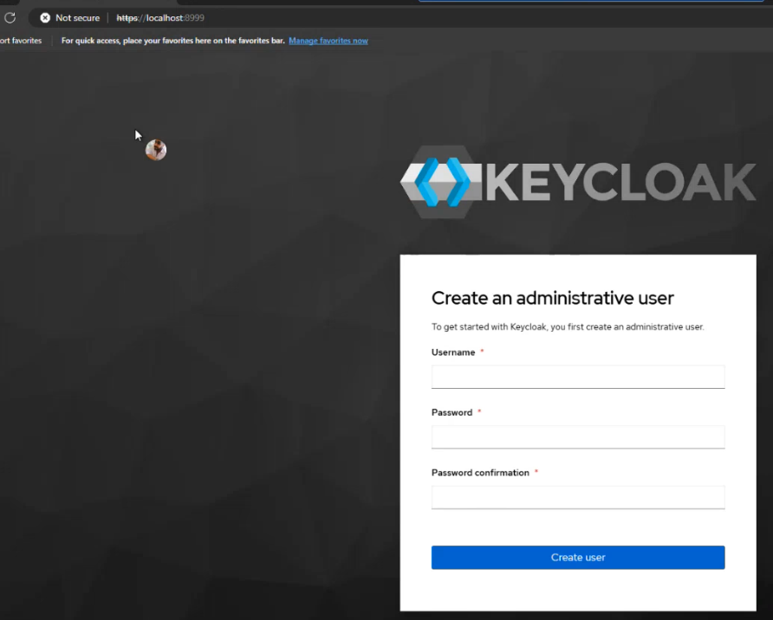

1. Post creation you need to login into the portal, and you will see the dashboard of Keycloak then you must create

* A Realm by uploading the **“Opkey-Keycloak.json”** file.

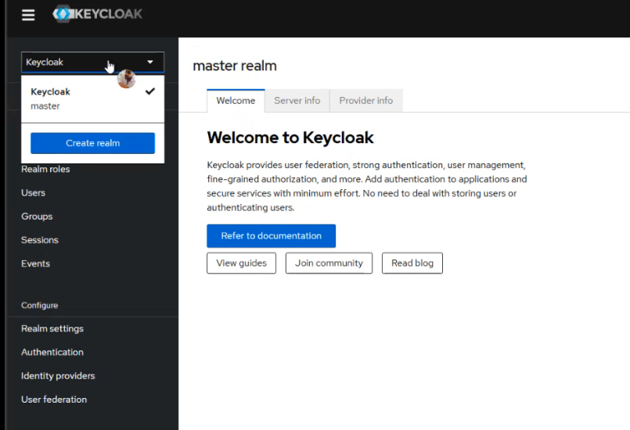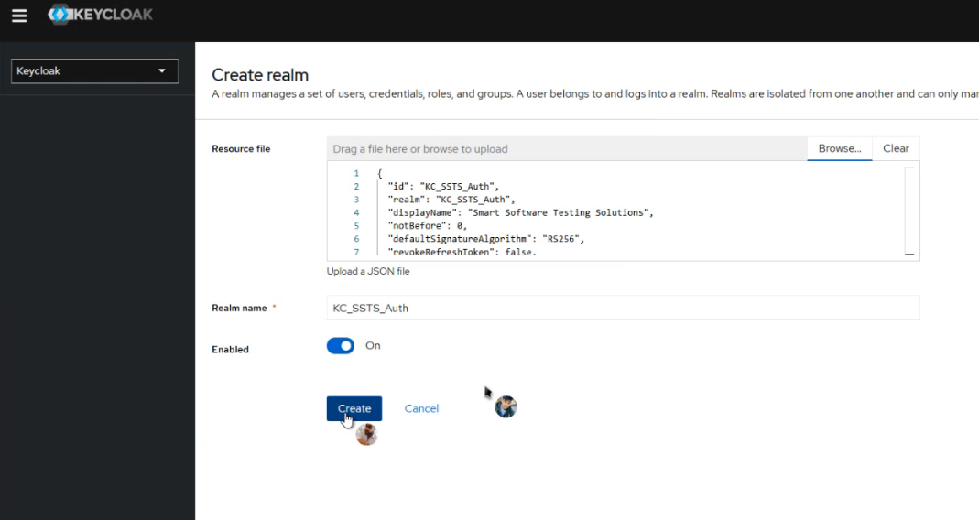

1. Now ensure that the **Frontend URL** must be blank in the **General** section under **Realm settings**

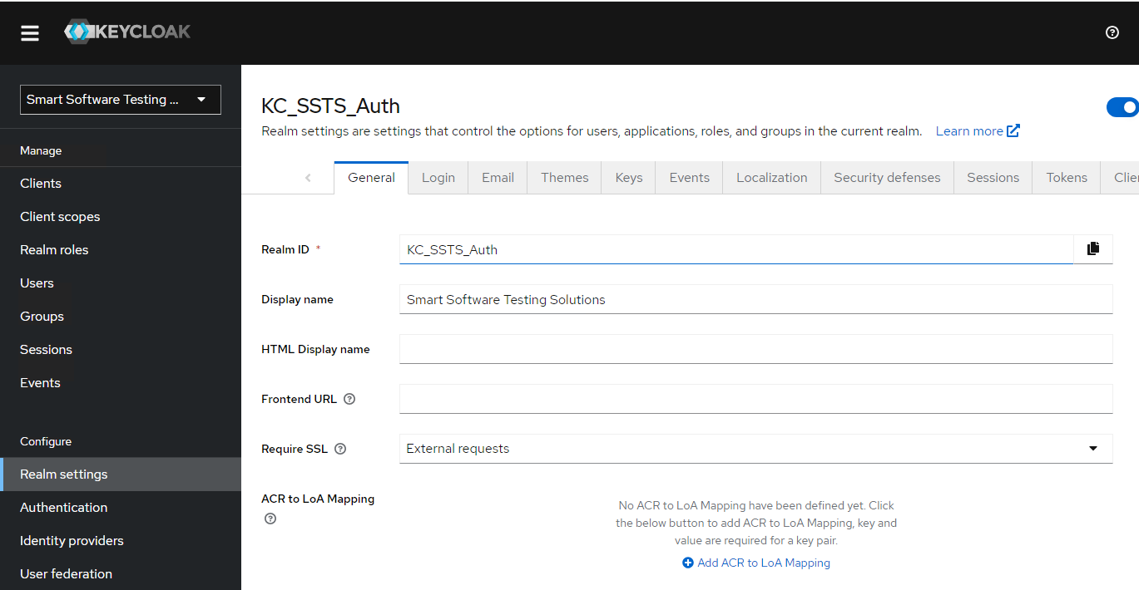

1. Now mention user details like **First Name**, **Last Name** and **Email** address in the admin user’s settings. You can open that page by selecting the username’s icon and select **Manage account**

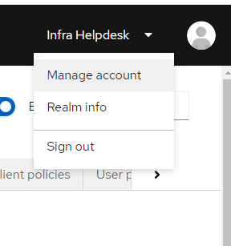

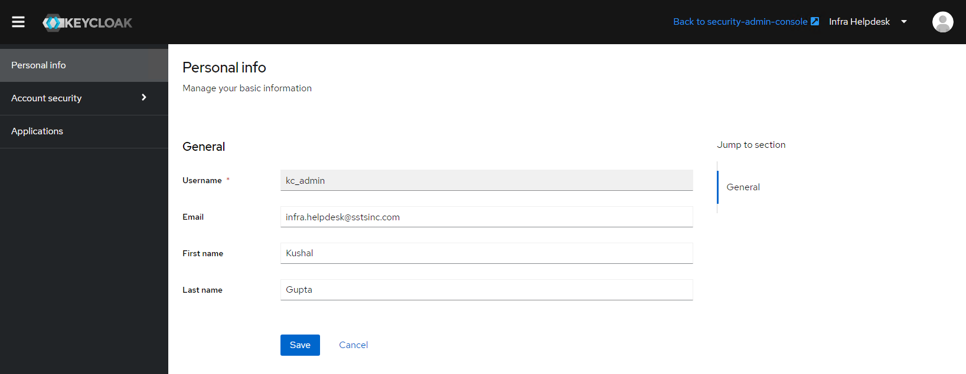

1. After mentioning the details save it and select **“Back to admin-security-controls”** and then setup STMP settings in **Email** section under **Realm settings** and verify them

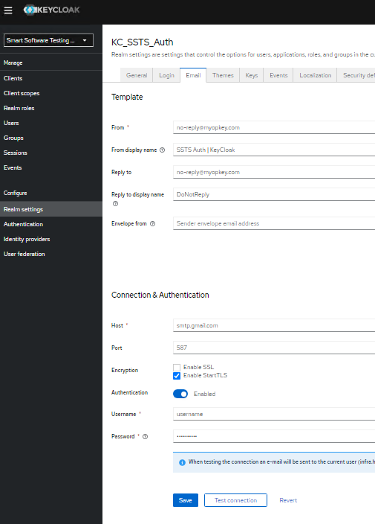

[In case the username and password are not visible, click on the toggle button next to the 'Authentication' option. If the toggle is already enabled, click it to disable it, and then click it again to re-enable it]

1. Go to the **Clients** menu from the left pane and click on **ssts-api** under **Clients list** section and open **Cresentials** tab. Here you need to regenerate the **Client Secret** token and keep it safe for later use in Opkey configurations.

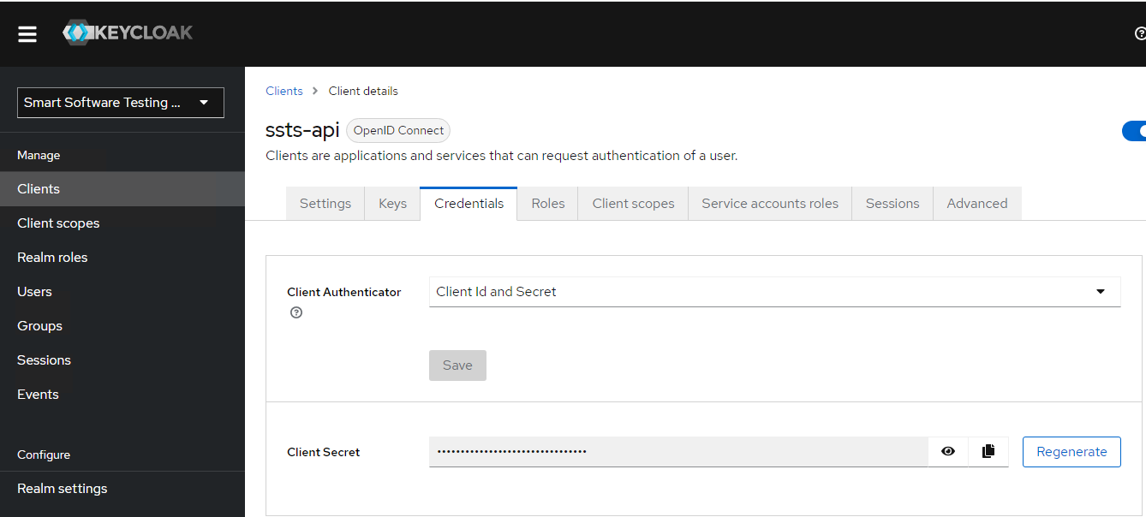

1. Now select the **Users** section and click on **Add User** then fill in the details to create a user (which will log into the Opkey portal as mentioned above in **Opkey Schema Creation** section) and hit create

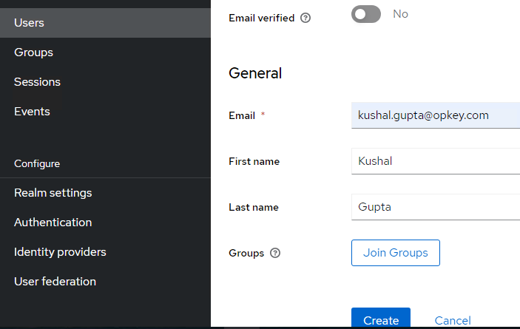

* Post creation open **Credentials** tab and click on **Set Password**

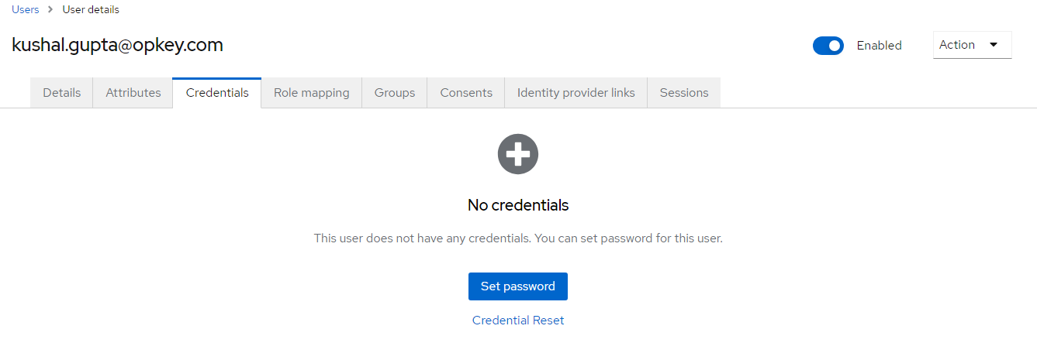

* Now set password for the user and disable **Temporary** option then hit save and hit **Save password** again as it confirms

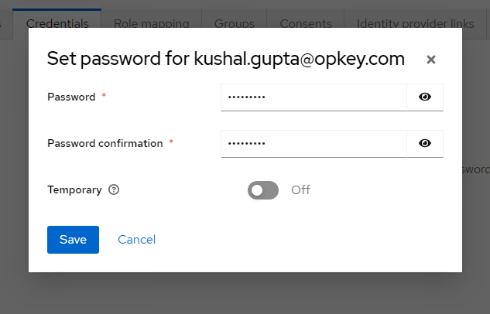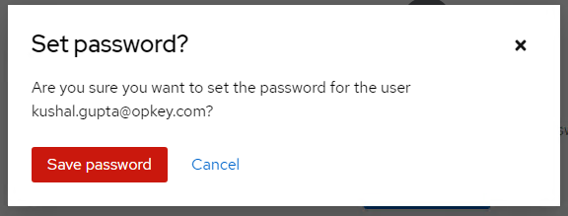

1. Now open **Realm settings** select the **Keys** tab and click on **Certificate** in the **RS256** section. Here we need to create a certificate that will be used later in the Opkey configurations.

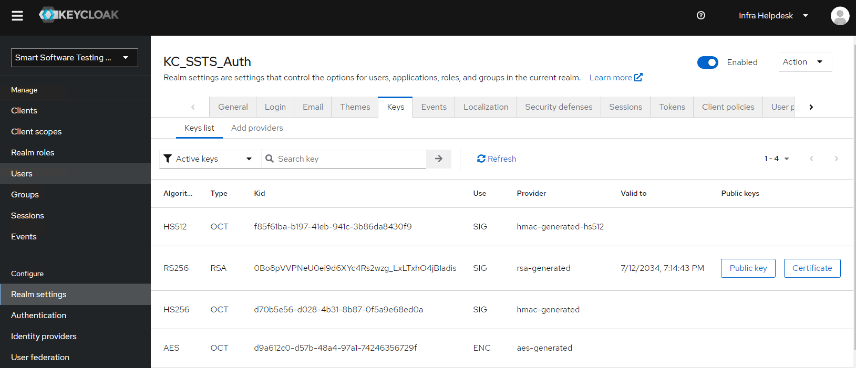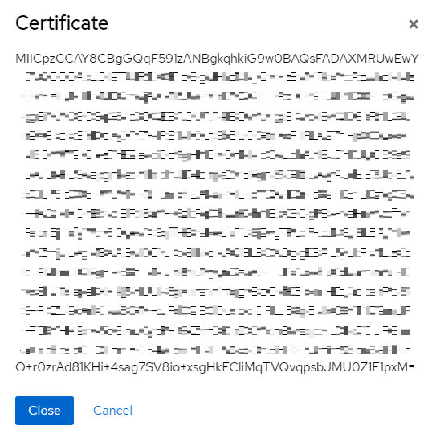

* Now copy the complete certificate value and paste it in a notepad and make a certificate **“.crt”** file with it
* To create the certificate file with the value you need to edit this value in that way which cuts down it in 64 bytes (characters) in each line and put **“----BEGIN CERTIFICATE----” “----END CERTIFICATE---”**, then save it **filename.crt** [You can refer to the image below]

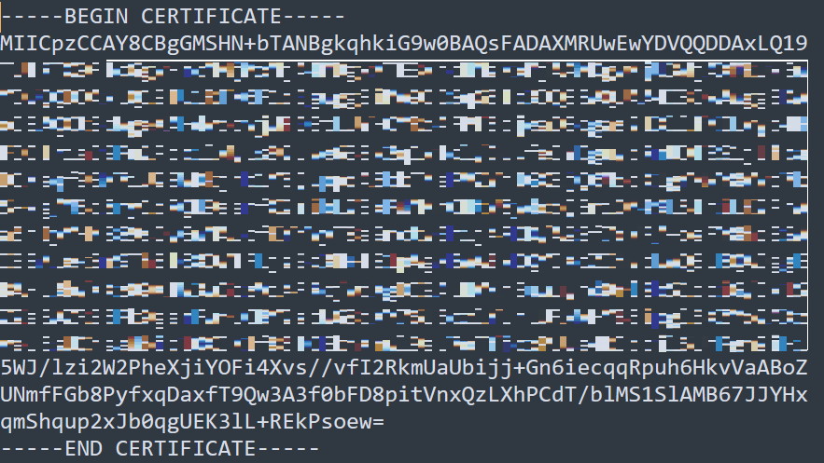

**16. Self-Signed SSL Certificate Creation**

**It is suggested that clients should share the Signed SSL Certificate (wildcard certificate preferable) with all the Opkey applications. However, if it is not possible at their end it must be configured with the below mentioned steps.**

* Here we need to execute a command on PowerShell (should be open as administrator) to create a self-signed certificate.

**New-SelfSignedCertificate -DnsName *.domainname.com -NotAfter (Get-Date).AddYears(10) -CertStoreLocation cert:\LocalMachine\My**

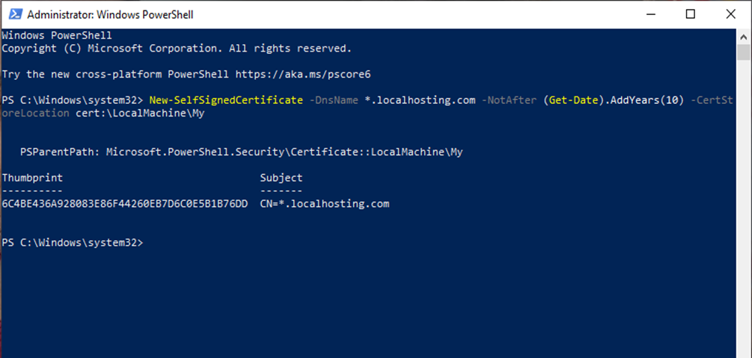

**17. Hosting of Opkey Web, Transpiler Server and ARR Builds**

1. We will host Opkey Web and ARR on the App Server. So, first, let’s deploy ARR build (provided by the Opkey team) on the App Server on the IIS Manager.

* Open IIS Manager and expand hierarchy folders as show below

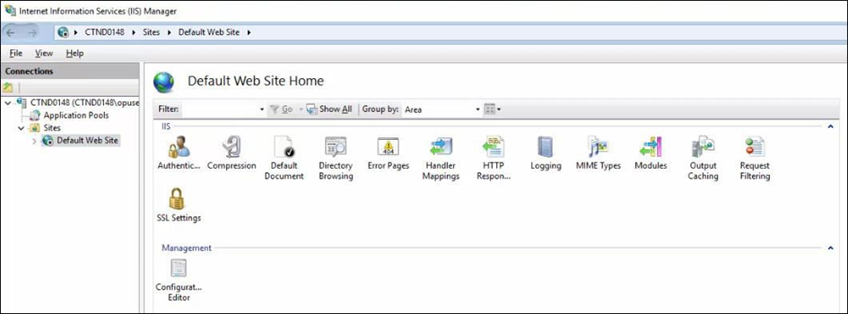

* Right click on the **Default Web Site** and click on **Remove** to delete it

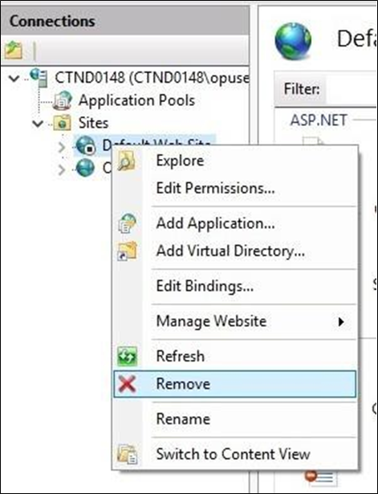

* Click on Yes

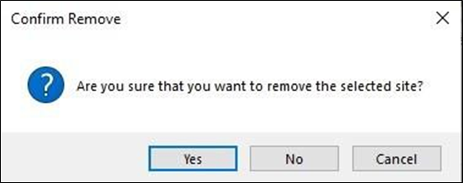

* The **Default Web Site** has been deleted
* You’ll have to also delete the **“Default Application Pool”**

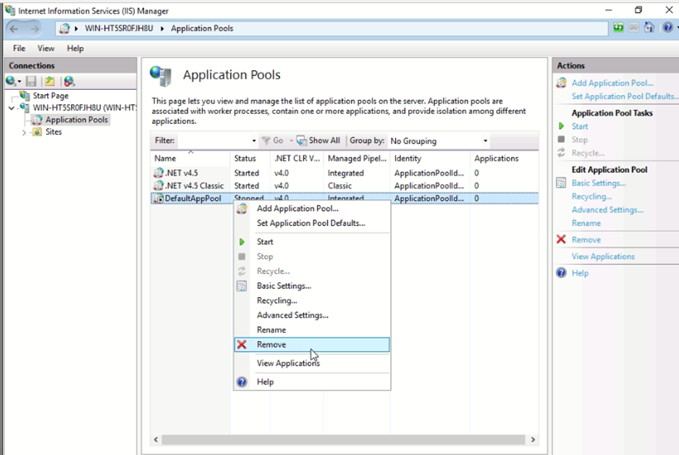

* Right click on **Sites** and click on **Add Website** option

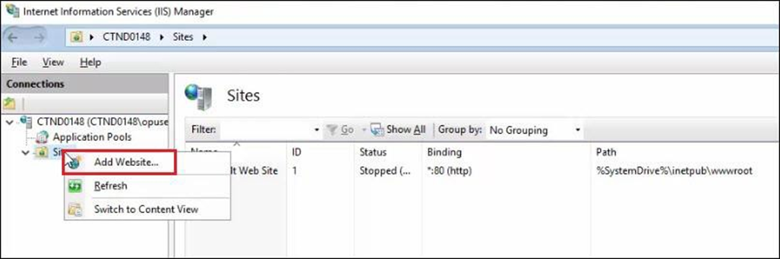

* Provide the path for ARR Website and provide all the details and select the SSL certificate which we have created earlier in the above step (Section 16)

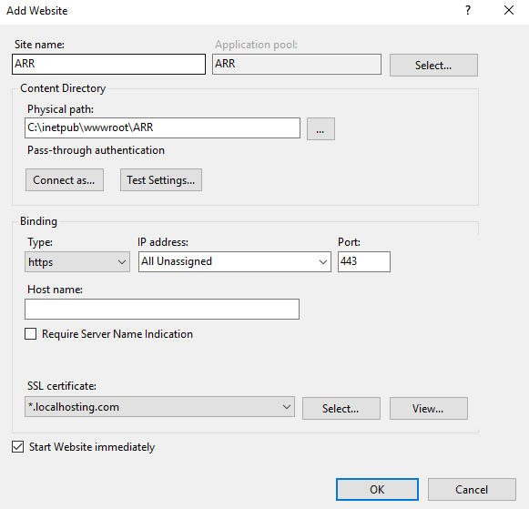

* Click on **OK** and select **URL Rewrite**

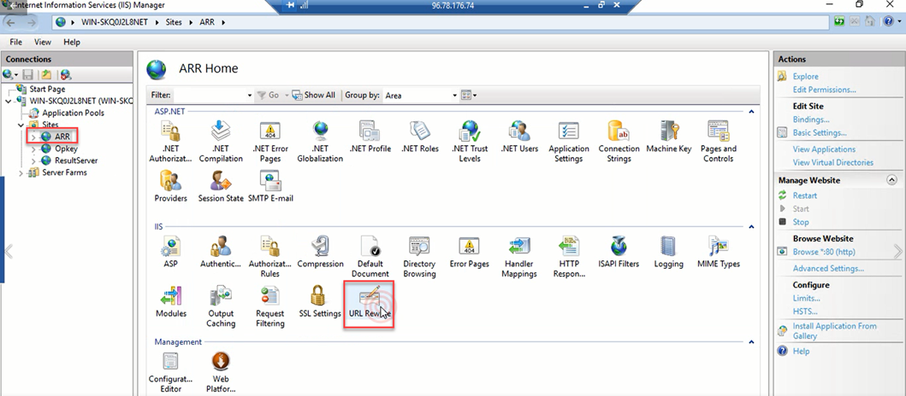

* Click on the **View Server Variables** present on the right column. Click on **Add** and provide details

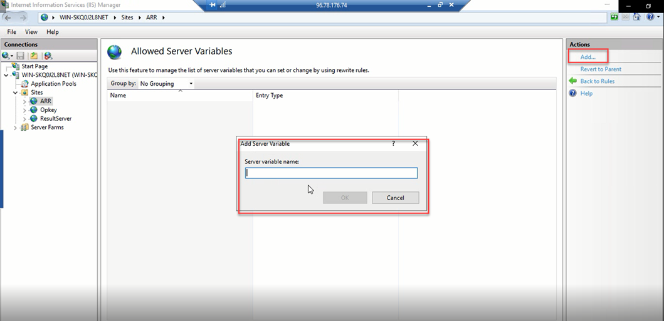

* Add three variables of **HTTP_X-Forwarded-Port**, **HTTP_X-Forwarded-Host** and **HTTP_X-Forwarded-Proto**

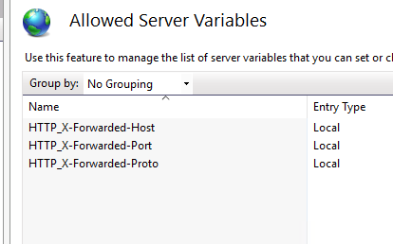

* Open IIS Manager and select **Server** and double click on **Application Request Routing Cache** and click on **Server Proxy Settings** present on the right-hand panel and select **Enable Proxy** and **Apply**

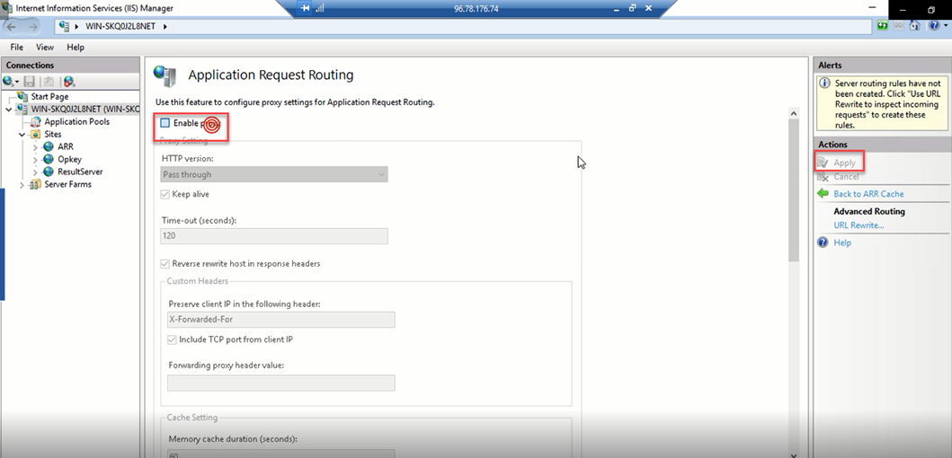

* Now select **ARR** site and double click on **URL Rewrite**



* Now you need to make **inbound rules** to for all the applications which will be running on different servers with their path and redirection URLs with port numbers as shown below **[When you configure a rule for Opkey-Web, ensure that you must add a server variable HTTP_X-Forwarded-Host and the value must be Opkey URL as shown below in the 2nd image]**

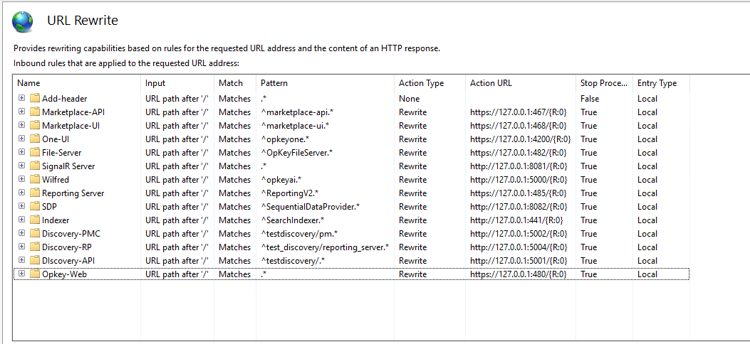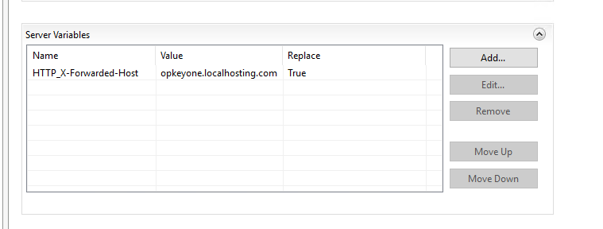

1. Now we will host Opkey Web.

* Open IIS Manager and right click on **Sites** and click on **Add Website** option



* Provide the path for Opkey Web website and provide all the details and select the SSL certificate which we have created earlier in the above step (Section 16)

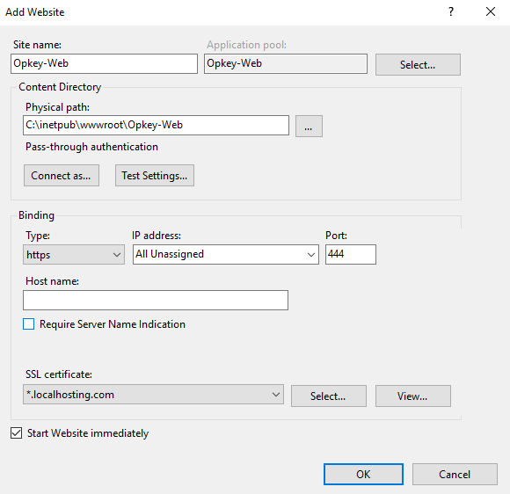

* Right click on the added site name and then click on **Explore**

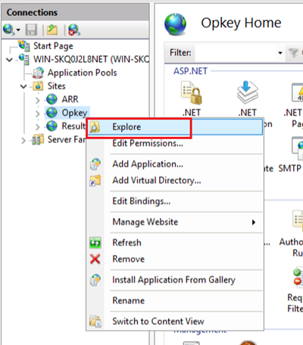

* Extract the compressed folder of Opkey bundle (provided by Opkey team) and select all the files and folders, make a copy here **“C:\inetpub\wwwroot\Opkey-Web”** (Opkey We path which we create in the above steps) The user should have admin rights to do this

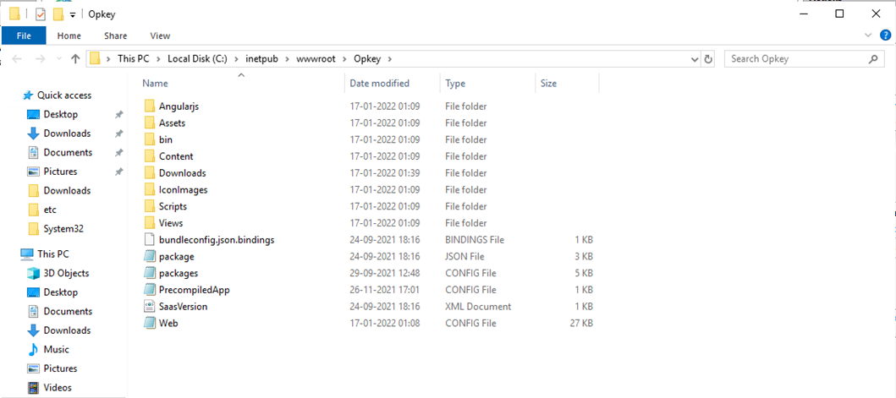

* Now, edit **“web.config”** file **(Changes are mentioned in the Opkey-Config Values.xlsx file)**
* Now, go to **“C:\Windows\System32\drivers\etc”** and edit the **Hosts** file and make below entriy at the end to create a local URL or you can make DNS entries in your org DNS server (If you are doing DNS server entry then you don’t need to create this entry)

127.0.0.1 opkey.localhosting.com

* Now, open **Internet Explorer** as **“Run as Administrator”**. Hit the local URL of Opkey Web i.e **https://localhost:444**
* The screen below will be displayed, where you need to click on the **More Information** tab and select **Go on to the webpage**

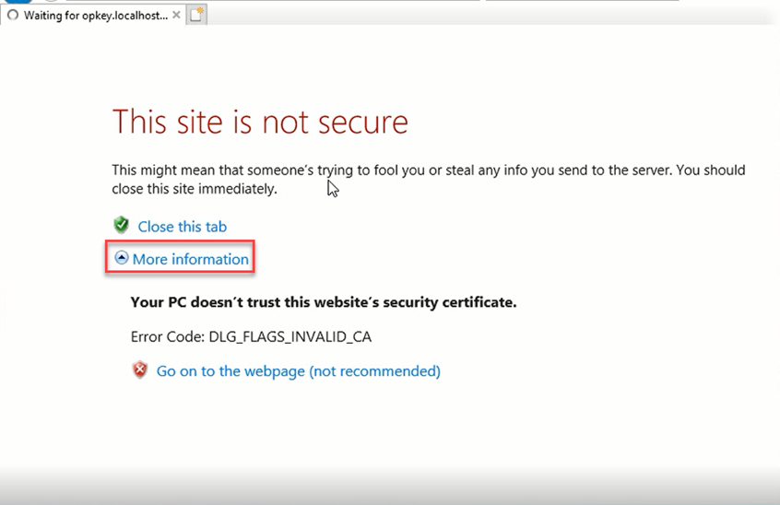

* Click on the **Certificate Error**, which will navigate to a window. Click on **View Certificates**

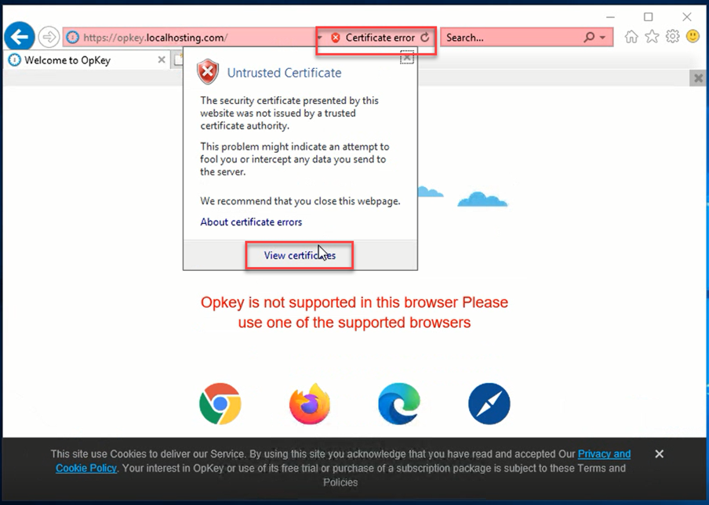

* In the next window, click on **Install Certificate** and click on **OK**

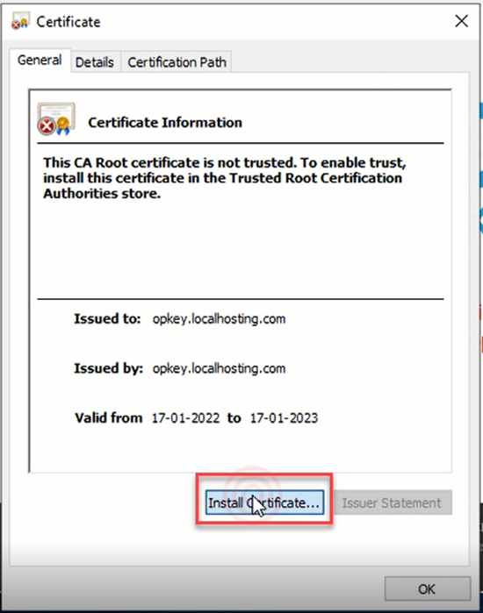

* In the next window click on the **Local Machine** radio button and proceed with **Next**

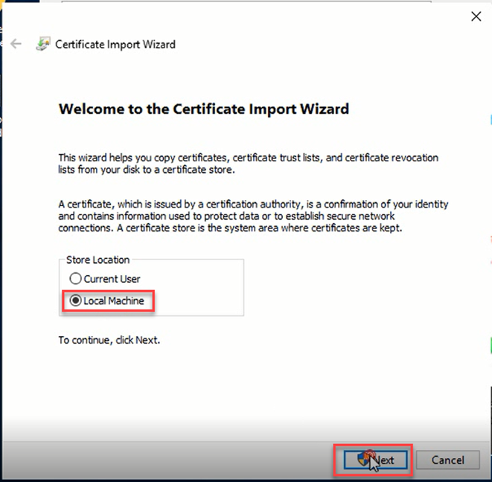

* For the next window, click on **“Place all certificates in the following store”** enter details of the Certificate Store and click on **OK**

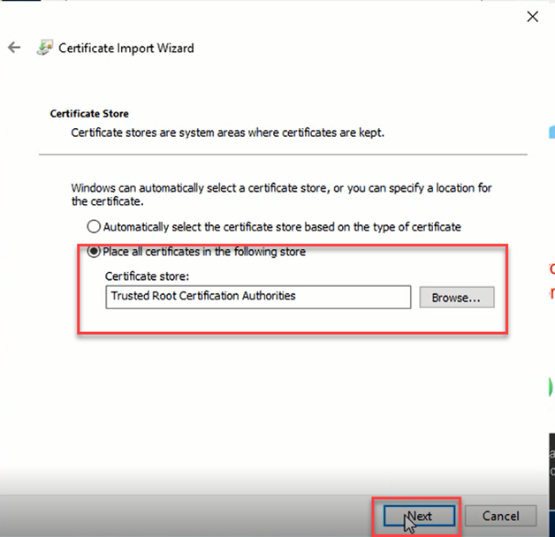

* Click on the **Certificate Completion** in the next window and proceed with the **Finish** button

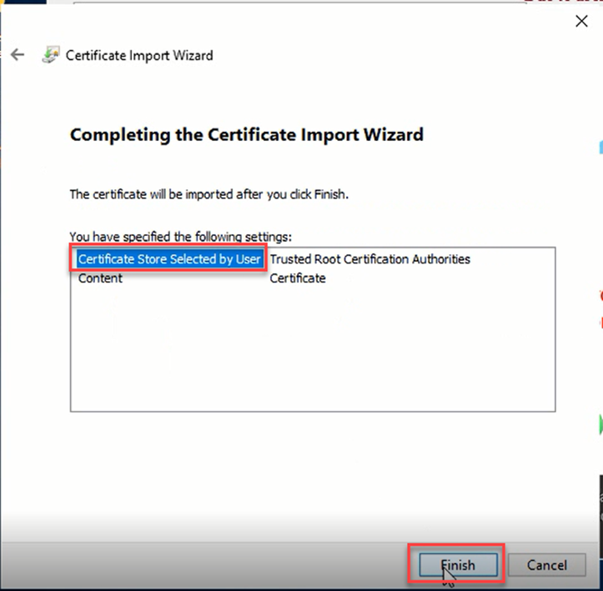

* Now we need to hit the Opkey URL again and verify the installation.

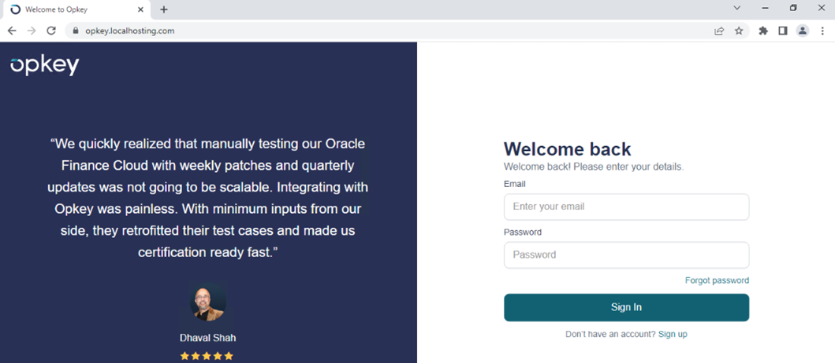

1. Now we will host Transpiler Server which will run on **8443** port number by default. It will be hosted on the App Server.

* Go to **“C:\Windows\System32\drivers\etc”** and edit the **Hosts** file and make below entry at the end to create a local URL

127.0.0.1 transpiler.localserver.com

* Now, open **Internet Explorer** as **“Run as Administrator”**. Hit the local URL of Opkey Web i.e **https://localhost:8443**
* The screen below will be displayed, where you need to click on the **More Information** tab and select **Go on to the webpage**



* Click on the **Certificate Error**, which will navigate to a window. Click on **View Certificates**

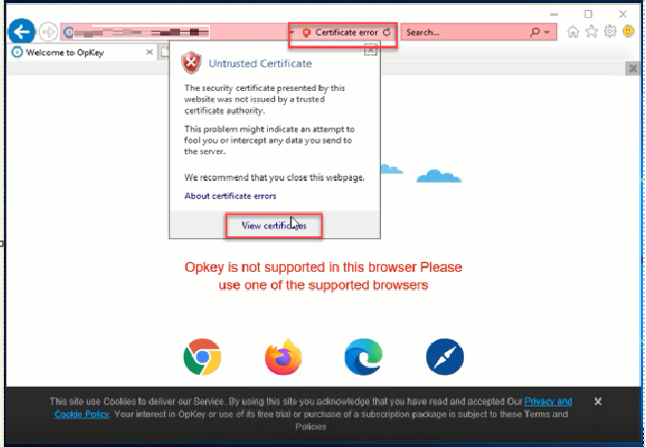

* In the next window, click on **Install Certificate** and click on **OK**

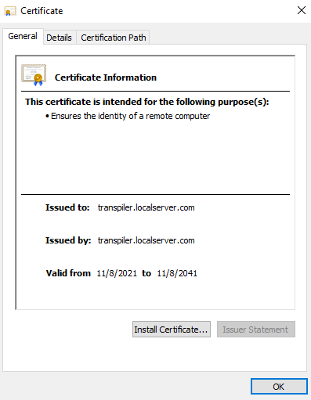

* In the next window click on the **Local Machine** radio button and proceed with **Next**



* For the next window, click on **“Place all certificates in the following store”** enter details of the Certificate Store and click on **OK**



* Click on the **Certificate Completion** in the next window and proceed with the **Finish** button



* Now we need to hit the Transpiler Server URL again and verify the installation.

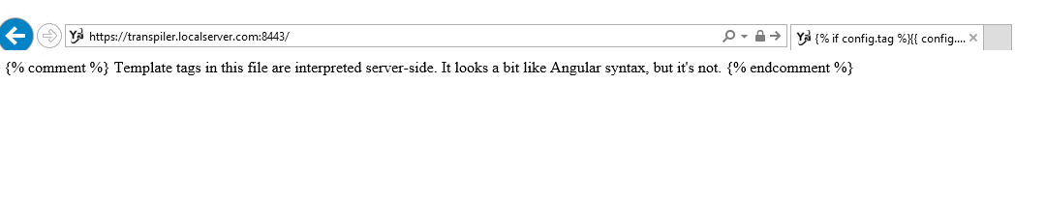

**18. Hosting of File Server**

* The File Server will be hosted on the Result Server machine. We must perform the same steps as in the above section **17.A and 17.B**
* Add website for File Server
* Fill all the details **Site Name**, **Physical Path**, **Port number, Protocol** and **SSL Certificate**

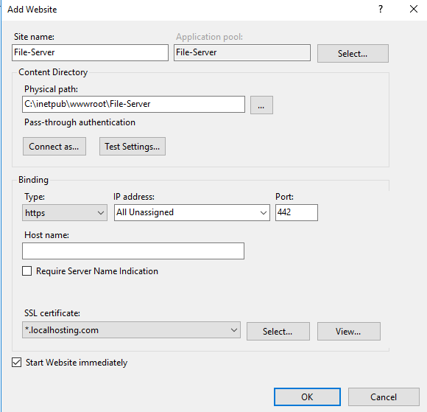

* Then create an entry in the hosts file or DNS server for File Server

127.0.0.1 file.localhosting.com

* Then we must create an ARR inbound rule for File Server
* Open File-Server folder and edit **“appsettings.json”** file then change the flag values **(as mentioned in the Opkey-Config Values.xlsx file)**
* After hosting File Server, you can check verify it by hitting the URL and its API in a browser

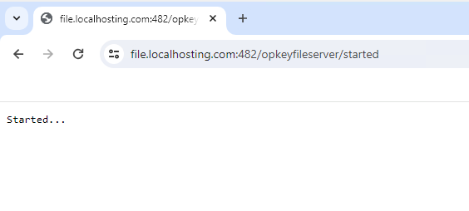

**19. Hosting of Result Server**

* The Result Server will be hosted on the Result Server machine. We must perform the same steps as in the above **section 17.A and 17.B**
* Add website for Result Server
* Fill all the details **Site Name**, **Physical Path**, **Port number, Protocol** and **SSL Certificate**

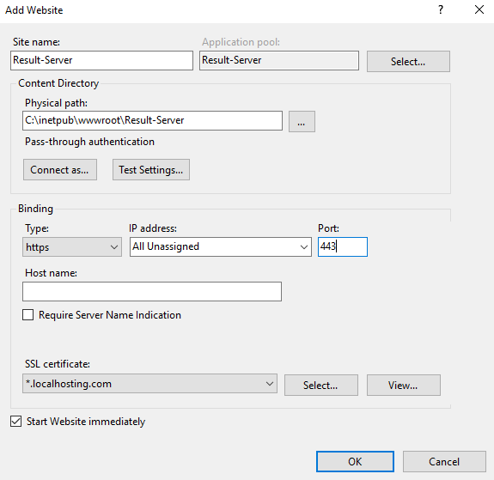

* Then create an entry in the hosts file or DNS server for Result Server

127.0.0.1 result.localhosting.com

* Then we must create an ARR inbound rule for Result Server
* Open Result-Server folder and edit **“web.config”** file then change the flag values **(as mentioned in the Opkey-Config Values.xlsx file)**
* After hosting Result Server, you can check verify it by hitting the URL in a browser

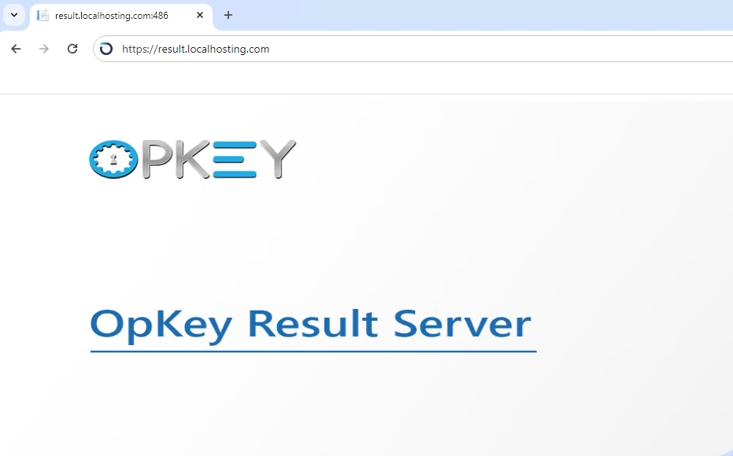

**20. Hosting of Multi-Browser Server**

* The Multi-Browser Server will be hosted on the Result Server machine. We must perform the same steps as in the above **section 17.A and 17.B**
* Add website for Multi-Browser Server
* Fill all the details **Site Name**, **Physical Path**, **Port number, Protocol** and **SSL Certificate**

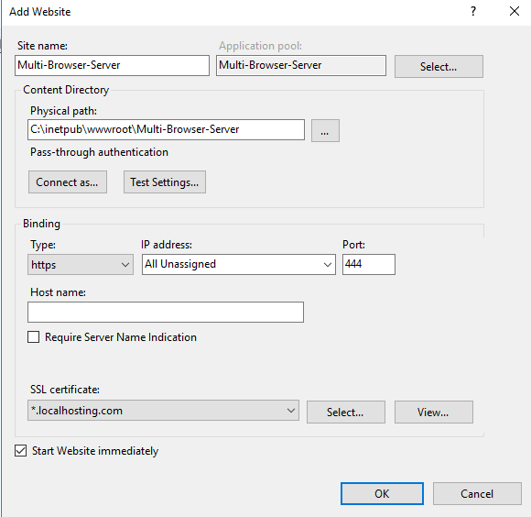

* Then create an entry in the hosts file or DNS server for Multi-Browser Server

127.0.0.1 mbs.localhosting.com

* Then we must create an ARR inbound rule for Multi-Browser Server
* Open Multi-Browser Server folder and edit **“web.config”** file then change the flag values **(as mentioned in the Opkey-Config Values.xlsx file)**
* After hosting Multi-Browser Server, you can check verify it by hitting the URL in a browser

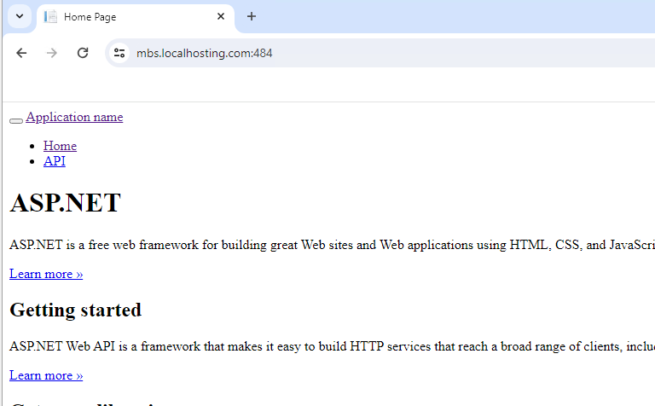

**21. Hosting of DevOps Server**

* The DevOps Server will be hosted on the Result Server machine. We must perform the same steps as in the above **section 17.A and 17.B**
* Add website for DevOps Server
* Fill all the details **Site Name**, **Physical Path**, **Port number, Protocol** and **SSL Certificate**

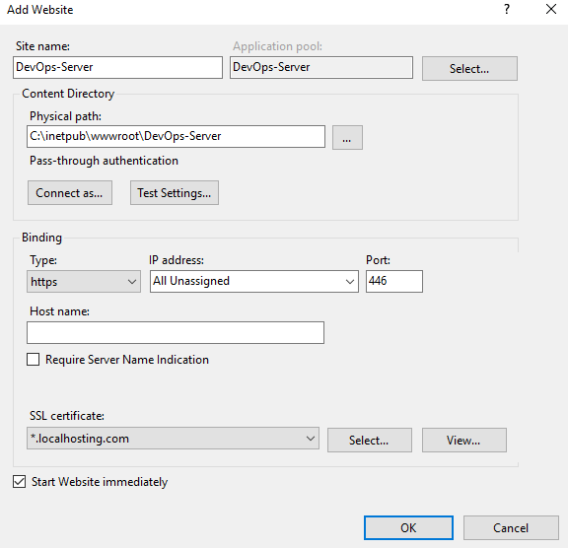

* Then create an entry in the hosts file or DNS server for DevOps Server

127.0.0.1 devops.localhosting.com

* Then we must create an ARR inbound rule for DevOps Server
* Open DevOps folder and edit **“web.config”** file then change the flag values **(as mentioned in the Opkey-Config Values.xlsx file)**
* After hosting DevOps Server, you can check verify it by hitting the URL and its API in a browser

**22. Hosting of Logging Server**

* The Logging Server will be hosted on the Result Server machine. We must perform the same steps as in the above **section 17.A and 17.B**
* Add website for Logging Server
* Fill all the details **Site Name**, **Physical Path**, **Port number, Protocol** and **SSL Certificate**

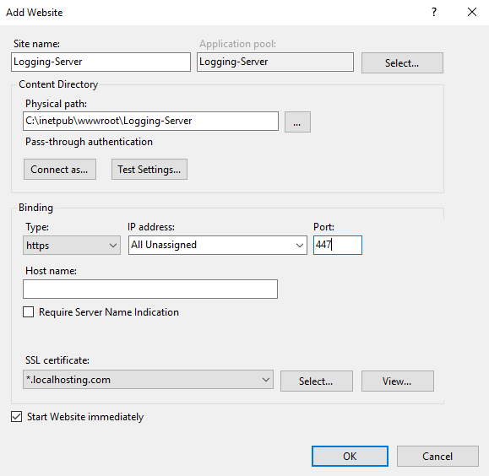

* Then create an entry in the hosts file or DNS server for Logging Server

127.0.0.1 loggingserver.localhosting.com

* Then we must create an ARR inbound rule for Logging Server
* Open Logging Server folder and edit **“web.config”** file then change the flag values **(as mentioned in the Opkey-Config Values.xlsx file)**
* After hosting Logging Server, you can check verify it by hitting the URL and its API in a browser

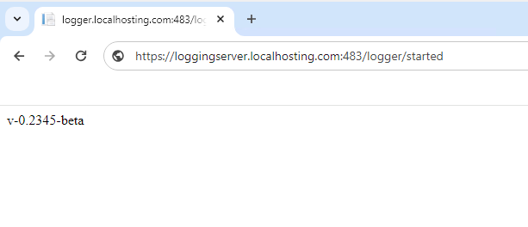

**23. Hosting of Reporting Server**

* The Reporting Server will be hosted on the Reporting Server machine. We must perform the same steps as in the above **section 17.A and 17.B**
* Add website for Reporting Server
* Fill all the details **Site Name**, **Physical Path**, **Port number, Protocol** and **SSL Certificate**

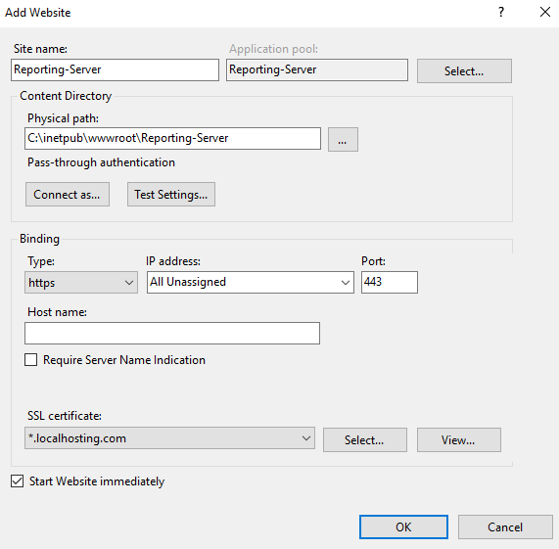

* Then create an entry in the hosts file or DNS server for Reporting Server

127.0.0.1 reportingserver.localhosting.com

* Then we must create an ARR inbound rule for Reporting Server
* After hosting Reporting Server, you can check verify it by hitting the URL and its API in a browser

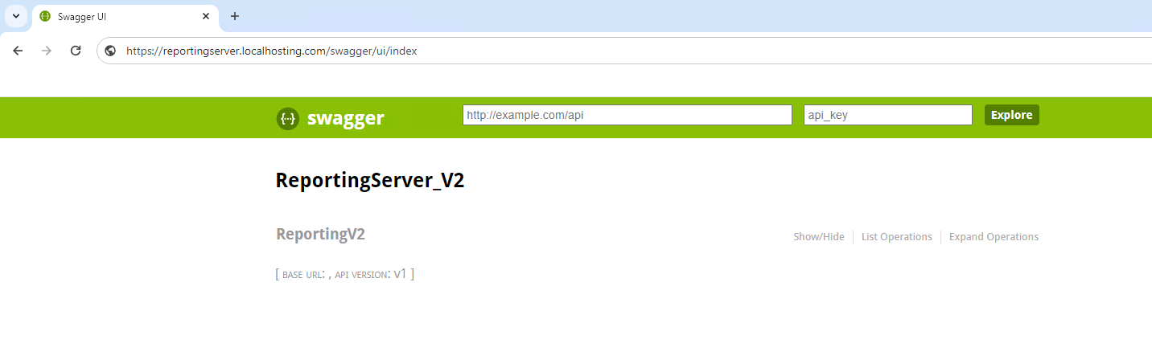

**24. Hosting of Indexer**

* The Indexer application will be hosted on Indexing Server.
* Copy the Indexer build (provided by Opkey team) to a folder in C or D drive and extract it. Then open the folder and edit **“appsettings.json”** file and change some values **(as mentioned in the Opkey-Config Values.xlsx file)**

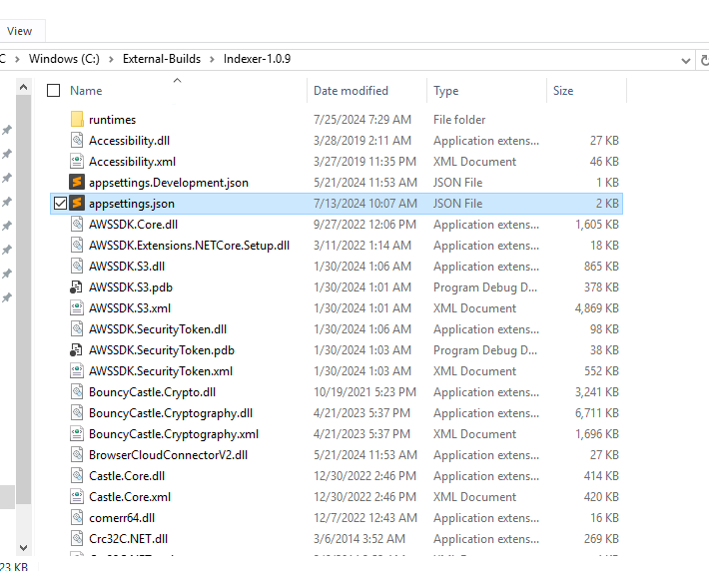

* After editing the configuration file, open CMD and run **SearchIndexingServiceWEB.exe**

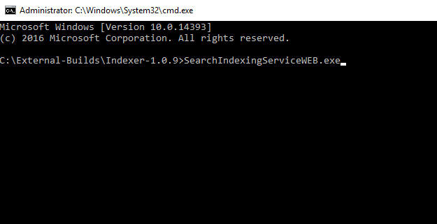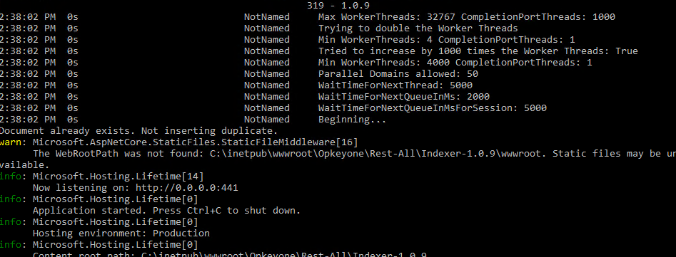

* After running this, you must create an ARR inbound rule for Indexer (as shown above in **section 17.A**)

**25. Hosting of Marketplace Server**

* The Marketplace Server build will be hosted on the Marketplace Server machine. After installing all the pre-requisites, first create a folder in C or D drive with the name **“Base_Addon_Dir”**
* Now open CMD and run the commands one by one as mentioned below
* npm install -g axios
* npm install -g ws
* npm install -g eval
* npm install -g http2
* npm install -g xlsx
* npm install -g date-and-time
* npm install -g jira-client
* npm install -g pm2
* npm install -g pm2-windows-startup
* pm2-startup install
* Now add **NODE_PATH** in system variables under environment variables settings and the value should be **“%AppData%\Roaming\npm\node_modules”** (this is the default path)

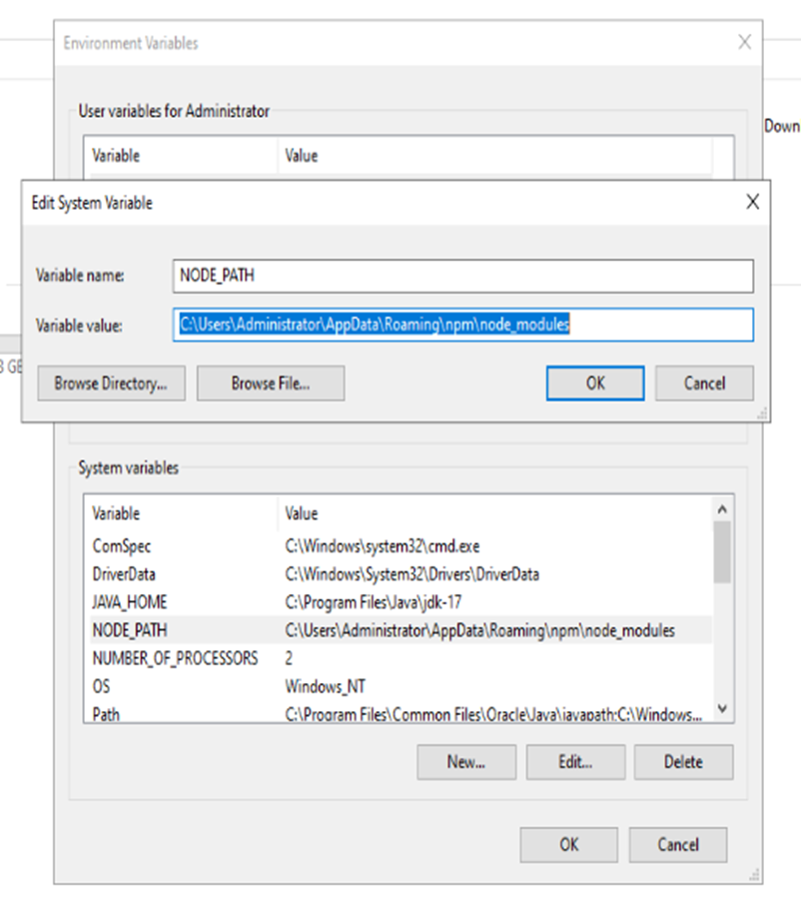

* Now copy the same **“node_modules”** path in the **Path** section

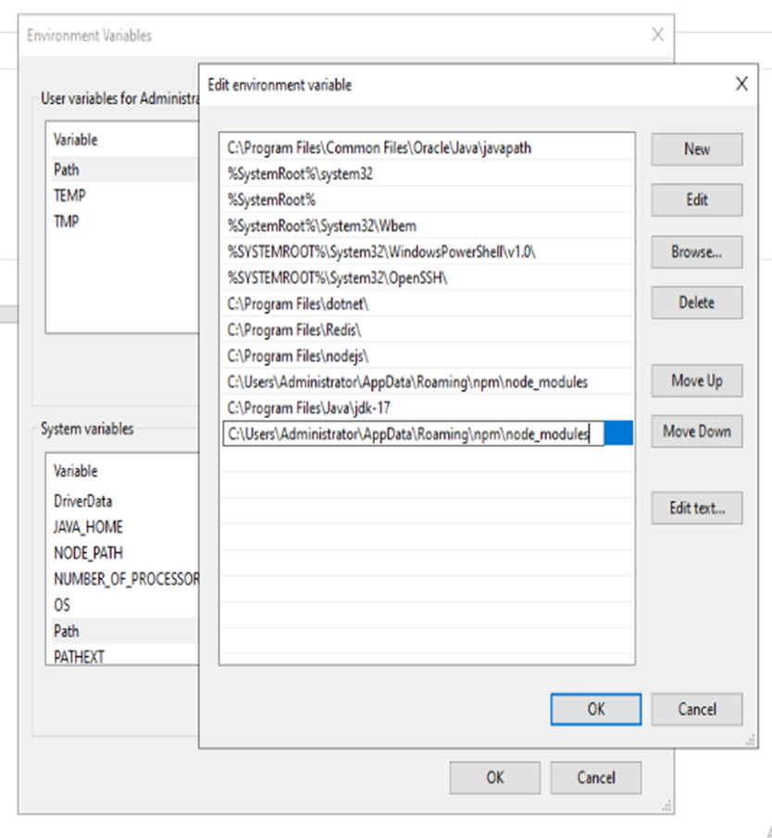

* Now open the command prompt and go to this folder **“C:\inetpub\wwwroot\Marketplace-API\Resources\NodeJSHelper”** and execute below mentioned commands one by one

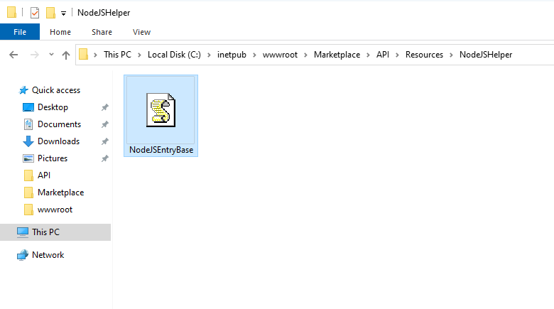

* pm2 start NodeJSEntryBase.js

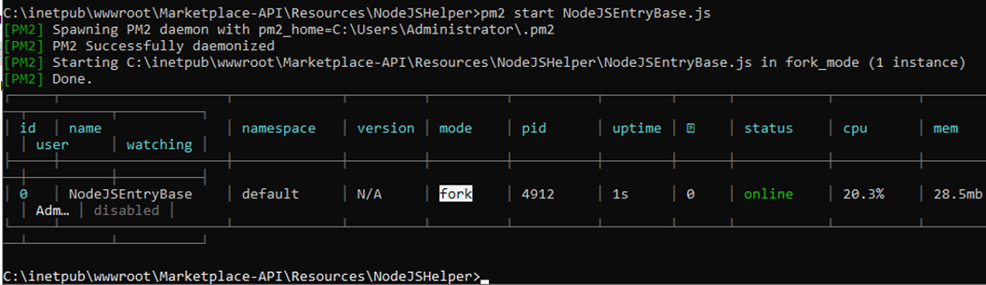

* pm2 save

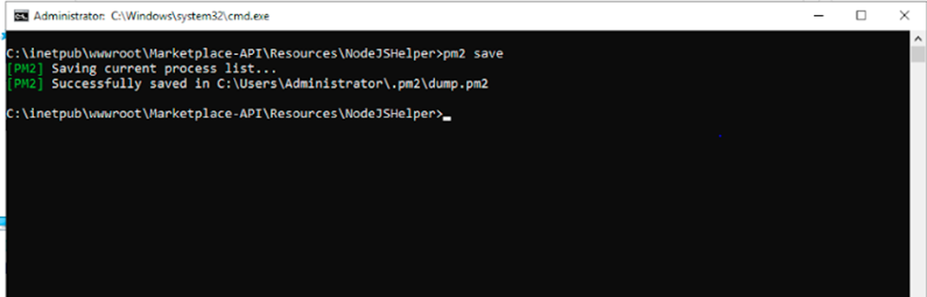

* pm2 log

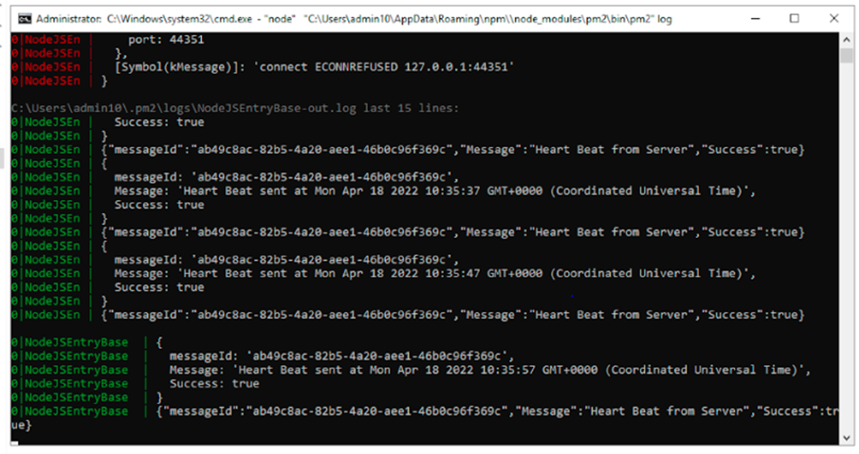

* Now follow the same steps as mentioned in the above **section 17.B** and with this machine, we create two websites, Marketplace-API and Marketplace-UI.
* Add website for Marketplace-API Server
* Fill all the details **Site Name**, **Physical Path**, **Port number, Protocol** and **SSL Certificate**

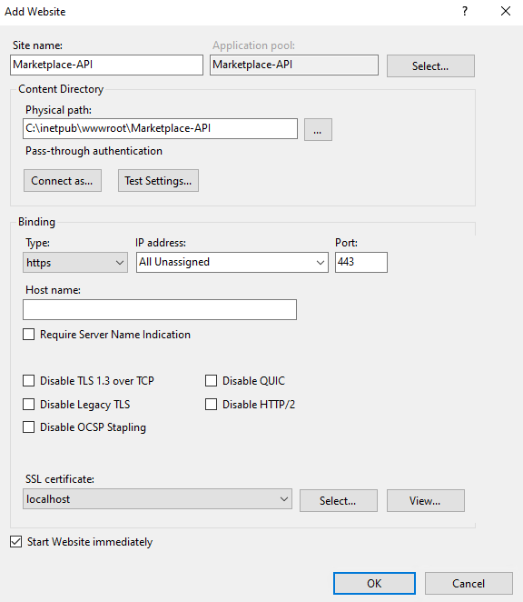

* Open Marketplace-API folder and edit **“web.config”** file then change the flag values **(as mentioned in the Opkey-Config Values.xlsx file)**
* Then we must create an ARR inbound rule for Marketplace-API Server
* After hosting Marketplace-API Server, you can check verify it by hitting the URL and its API in a browser

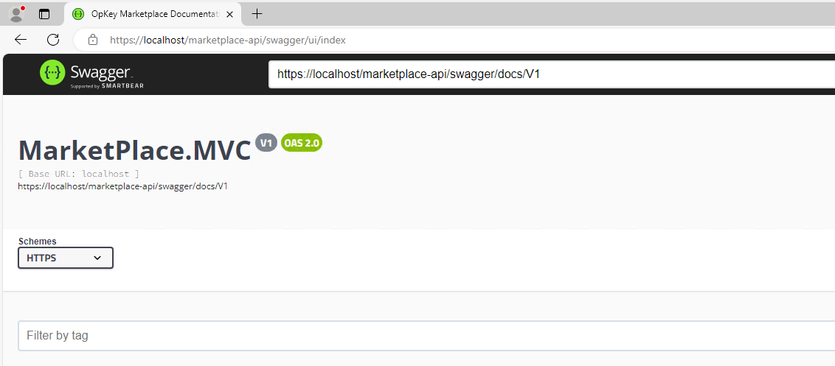

* Now hosting Marketplace-UI
* Add website for Marketplace-UI Server
* Fill all the details **Site Name**, **Physical Path**, **Port number, Protocol** and **SSL Certificate**

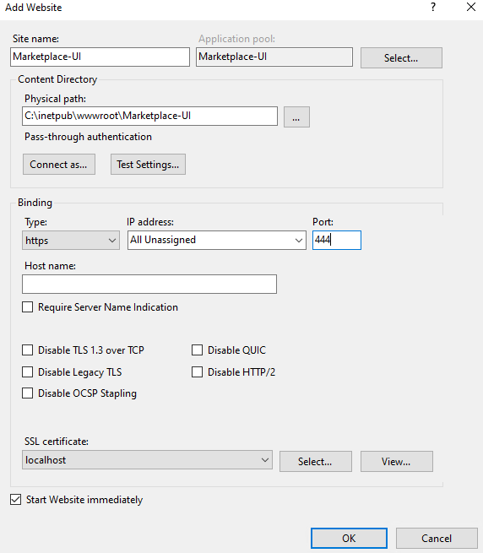

* Then we must create an ARR inbound rule for Marketplace-UI Server
* After hosting Marketplace-UI Server, you can check verify it by hitting the URL and its API in a browser

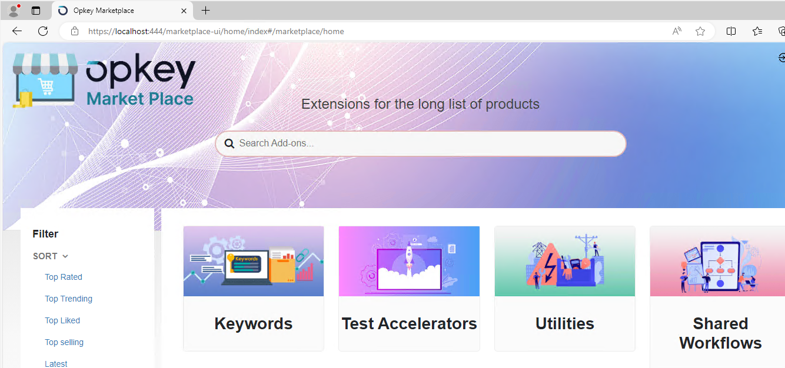

**26. Hosting of UI Server**

* After installing all pre-requisites, the UI Server build will be hosted on the UI Server machine. We must perform the same steps as in the above **section 17.B**
* First, open IIS Manager and select the **Server** and double click on **Application Request Routing Cache** and click on **Server Proxy Settings** present on the right-hand panel and select **Enable Proxy** and **Apply**

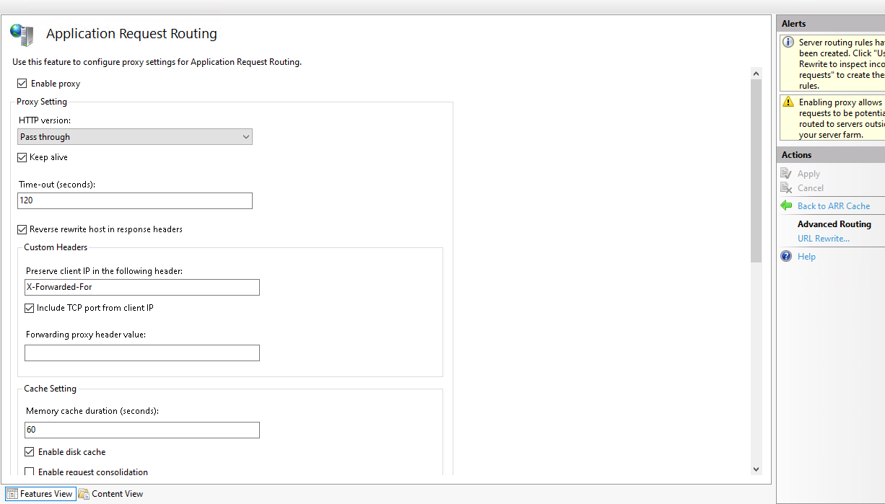

* Add website for UI Server
* Fill all the details **Site Name**, **Physical Path**, **Port number, Protocol** and **SSL Certificate**

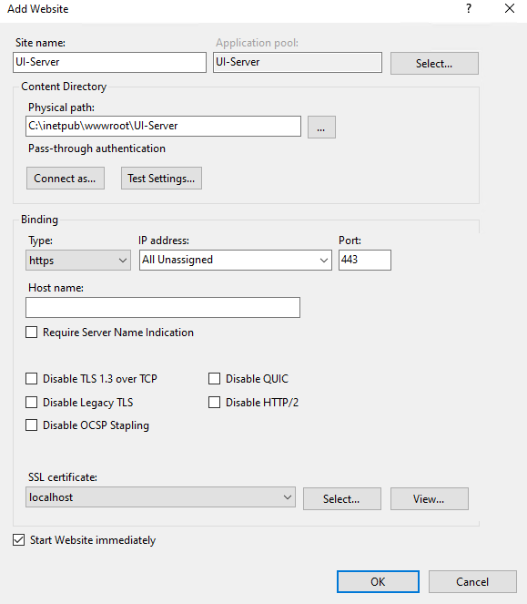

* Now, right click on the UI-Server website and select **Add Application** and put the **Alias “opkeyone”** and mention the same UI-Server folder path and click ok

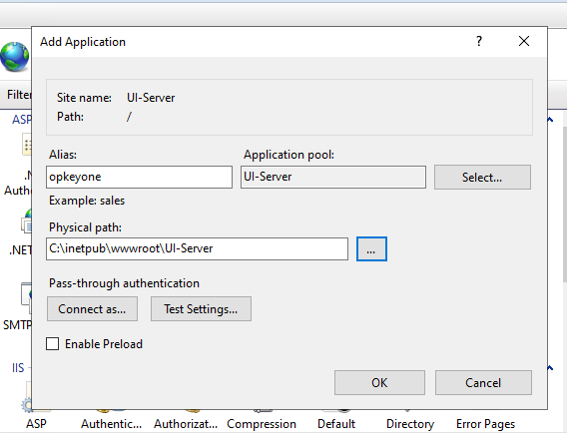

* Then we must create an ARR inbound rule for UI Server
* After hosting UI Server, you can check verify it by hitting the URL and its API in a browser

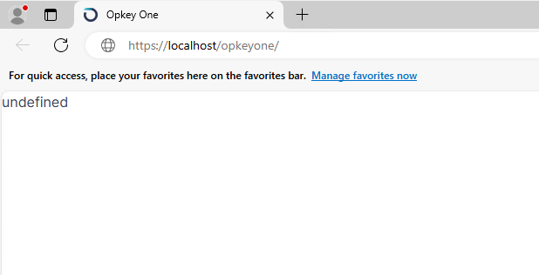

**27. Hosting of Test Discovery Applications**

**The Test Discovery server has five components/applications. We host three components in Test-Discovery Server 01 machine and rest two Test-Discovery Server 02 machine.**

1. Installation of **Discovery-API**, **Discovery-DB Maintainer** and **Discovery-DBC** applications/components

* Copy the builds (provided by Opkey team) in a folder in C or D drive and extract them

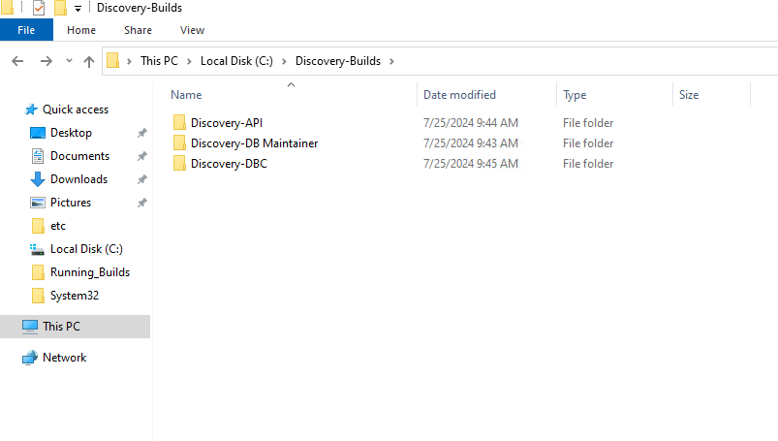

* Now open Discovery-DB Maintainer folder and open CMD, then run **“DB Maintainer CLI.exe”** file and start creating the database for Test Discovery by putting all the required details **(the database name must be created with the name of the Opkey schema name which we created earlier in the section 7)**
* Mongo DB Host Name – IP or DNS of Mongo DB server
* Mongo DB Port – Port number of Mongo DB server
* Mongo DB Username – Username of Mongo DB server’s admin
* Mongo DB Password – Password of the admin user
* TLS Enabled – n
* Do you want to upgrade all databases – n
* Observe IQ database – n
* Mongo DB Database name – opkey

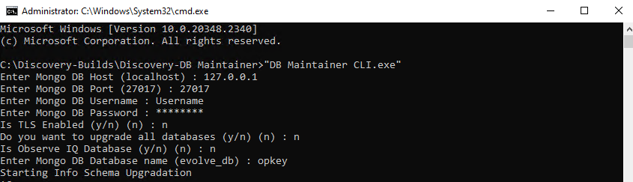

* Now open Discovery-DBC folder and edit **“appsettings.json”** file and change some values **(as mentioned in the Opkey-Config Values.xlsx file)**
* Then open CMD there and run **“Ssts.Evolve.DbConnector.Api.exe”** file **[This file must be running in the background all the time]**

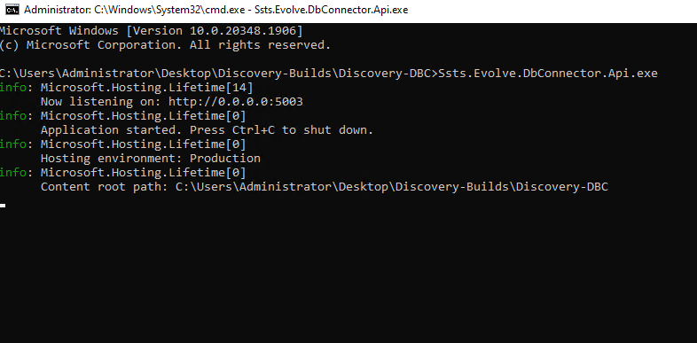

* Now open Discovery-API folder and edit **“appsettings.json”** file and change some values **(as mentioned in the Opkey-Config Values.xlsx file)**
* Then copy the Keycloak certificate which we have created in the **section 15.10** and paste it in **“Discovery-API\Resources\Certificates”**

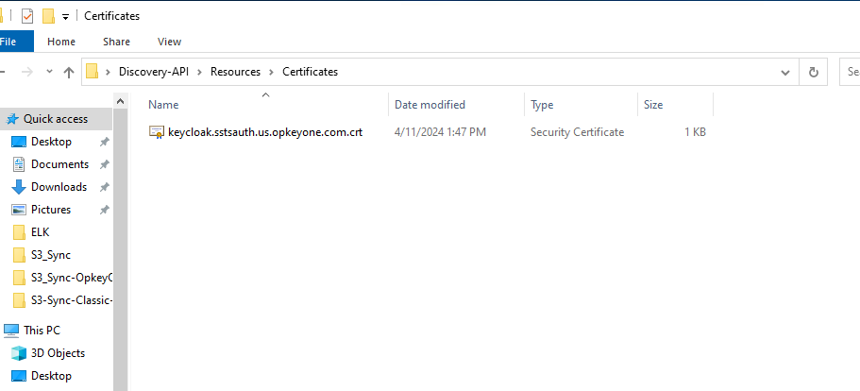

* Then open CMD there and run **“Opkey.TestDiscovery.Server.exe”** file **[This file must be running in the background all the time]**

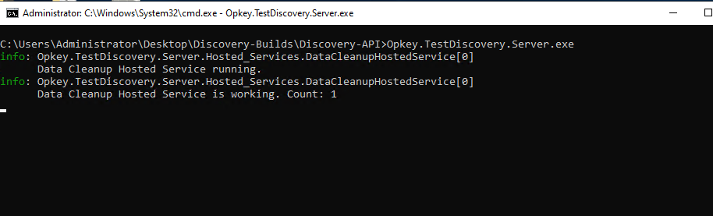

1. Installation of Discovery-PMC, and Discovery-Reporting applications/components

* Copy the builds (provided by Opkey team) in a folder in C or D drive and extract them

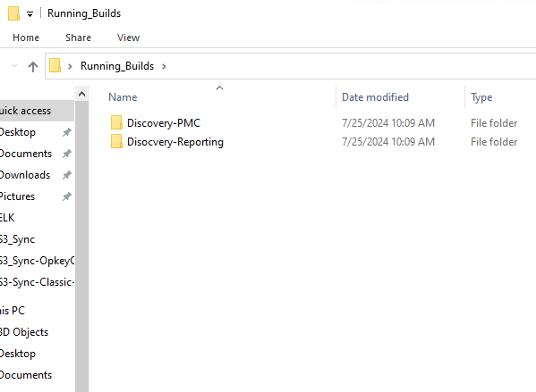

* Now open Discovery-PMC folder and edit **“configuration.ini”** file and change some values **(as mentioned in the Opkey-Config Values.xlsx file)**
* Then run **“server_start.exe”** file **[This file must be running in the background all the time]**

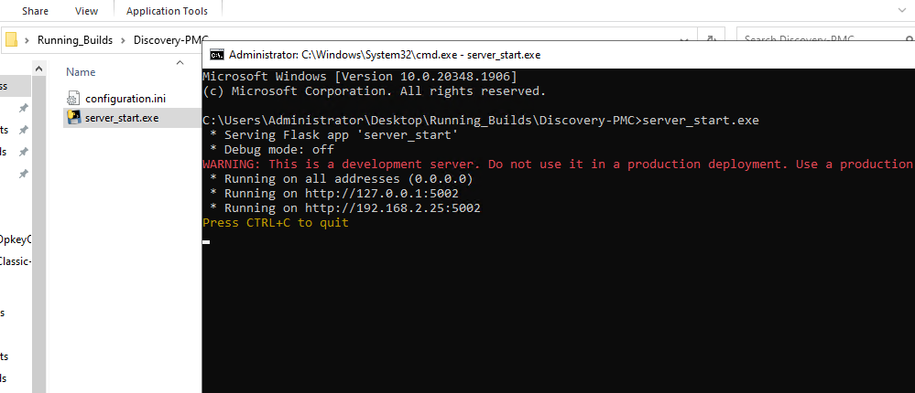

* Now open Discovery-Reporting run **“reporting_server_start.exe”** file **[This file must be running in the background all the time]**

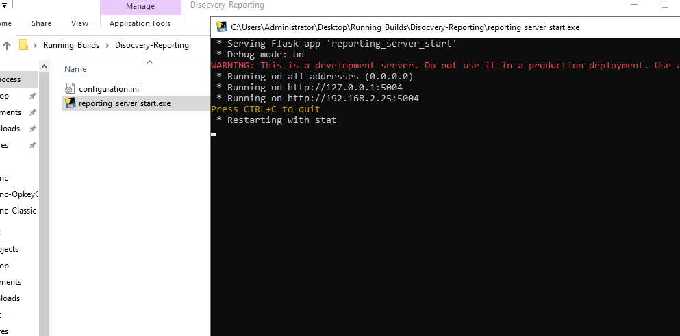

* After hosting the applications, we must create an ARR inbound rule for Test-Discovery API, PMC, DBC and Reporting.